Press Release
2023-179

Schmitz Cargobull AG

Schmitz Cargobull publishes second sustainability report in accordance with GRI standard

- Sustainability management systematically integrated throughout the organization

- Sustainability Strategy 2030 includes ambitious goals in eight areas of action along the three pillars: Products & Services, Environment and People

- Responsibility for sustainability anchored at board level in the Operations department

October 2023 - Schmitz Cargobull AG, a global family business and Europe's leading manufacturer of semi-trailers, has firmly anchored the issue of sustainability in its corporate strategy. The company assumes ecological and social responsibility along the entire value chain, pursuing the ambitious goal of making both the production processes throughout the network and the product portfolio sustainable. The sustainability strategy drawn up in 2022 is consistently geared towards the three fields of action of products & services, environment and people and includes all Schmitz Cargobull locations. This orientation is based on eight areas of action, through which the Schmitz Cargobull Group both defines substantive priorities and addresses the requirements of external stakeholders.

"The topic of sustainability is one of the great challenges of our time. Our industry is still at the very beginning when it comes to reducing environmental impact along the entire value chain and thinking of sustainability holistically," says Dr Günter Schweitzer, Chief Operations Officer and responsible for the sustainability strategy at Schmitz Cargobull.
"I am proud of the team and the fact that we have developed a comprehensive sustainability strategy within a good twelve months. We have set ourselves ambitious targets, such as reducing emissions across the entire production network by 90 per cent (Scopes 1 and 2)
by 2030 compared to the 2021/22 financial year. In the 2022/23 financial year, we were able to - adjusted for special effects such as the milder winter - we were already able to save
19.4 per cent energy. In addition, since 2023, 100 per cent certified green electricity has been used at all German production sites and CO₂e emissions have been reduced by 29 per cent overall and 24.5 per cent per trailer."

2023-179

With its sustainability strategy, Schmitz Cargobull is pursuing concrete goals in eight areas of action along the three pillars: products & services, environment and people.
The key topics are: sustainable transport solutions that are economical for customers, circular economy & recycling, energy, climate protection, materials, health & safety, supply chain responsibility and sustainability awareness.

The second sustainability report in accordance with the GRI reporting standard provides information on where the company has focused its content and how the international Schmitz Cargobull Group has developed with regard to important key figures and objectives in the area of sustainability. The report is now available in digital form and can be downloaded from the company's website: Download Sustainability Report 2022/23
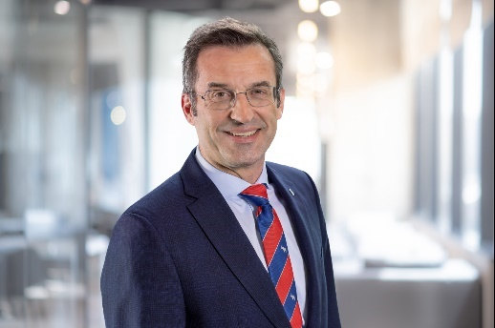

Dr Günter Schweitzer, Chief Operations Officer and responsible for the sustainability strategy at Schmitz Cargobull

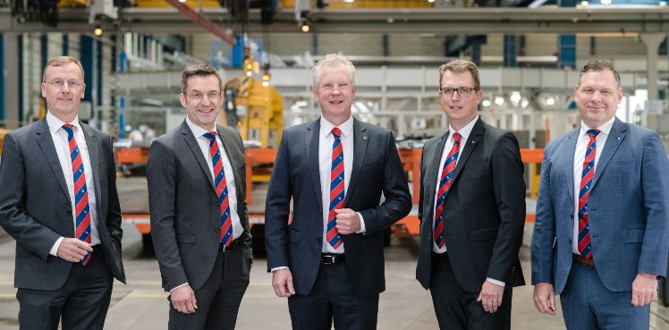

The Schmitz Cargobull Management Board
Andreas Busacker – Chief Financial Officer, Dr Günter Schweitzer – Chief Operations Officer, Andreas Schmitz – Chief Executive Officer, Marnix Lannoije – Chief Technical Officer, Boris Billich – Chief Sales Officer (f.l.)
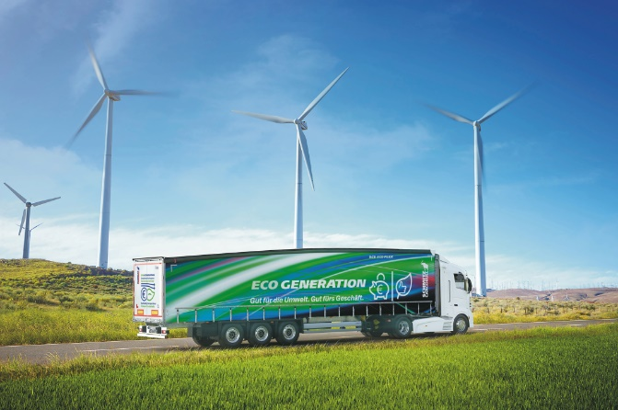

The aerodynamic S.CS EcoFLEX curtainsider semi-trailer from Schmitz Cargobull

2023-179

About Schmitz Cargobull
Schmitz Cargobull is the leading manufacturer of semi-trailers for temperature-controlled freight, general cargo and bulk goods in Europe and a pioneer in digital solutions for trailer services and improved connectivity. The company also manufactures transport refrigeration machines for refrigerated semi-trailers for temperature-controlled freight transport. With a comprehensive range of services from financing, spare parts supply, service contracts and telematics solutions to used vehicle trading, Schmitz Cargobull supports its customers in optimising their total cost of ownership (TCO) and digital transformation.
Schmitz Cargobull was founded in 1892 in Münsterland, Germany. The family-run company produces around 60,000 vehicles per year with over 6,000 employees and generated a turnover of around 2.6 billion euros in the 2022/23 financial year. The international production network currently comprises ten plants in Germany, Lithuania, Spain, England, Turkey, Slovakia and Australia.

The Schmitz Cargobull press team:
Anna Stuhlmeier +49 2558 81-1340 I anna.stuhlmeier@cargobull.com
Andrea Beckonert +49 2558 81-1321 I andrea.beckonert@cargobull.com
Silke Hesener +49 2558 81-1501 I silke.hesener@cargobull.com

