Press Release
2023-128

Schmitz Cargobull AG
Christian Renfordt appointed "Director Parts Sales"
at Cargobull Parts & Services GmbH

May 2023 - Christian Renfordt has taken over the position of Director Parts Sales at the Schmitz Cargobull subsidiary "Cargobull Parts & Services GmbH" with effect from 01.04.2023. In his role, he is responsible for sales, product management and pricing of international spare parts management at Schmitz Cargobull. As part of the management team, he reports directly to Britta Sprey, Managing Director of Cargobull Parts & Services.

Christian Renfordt, who has a degree in industrial engineering, has been working in the automotive aftermarket since 2002 and has held various sales and management positions. Most recently, he was Vice-President Europe-Africa at trailer coupling specialist Westfalia-Automotive.

"We are delighted to have been able to appoint Christian, an accomplished industry expert, for this position. With his profound expertise, he will continue to drive the success of our national and international spare parts sales and take it to the next level," says Britta Sprey.

"Quality spare parts, easy identification of spare parts and high availability are important for our customers. In the event of a repair, the trailer must be back on the road quickly. Because only a running trailer is successful and profitable," adds Christian Renfordt.
"In order to be able to react even faster to customer needs, we have a number of projects underway for even more efficient spare parts logistics. In addition to expanding the product and service portfolio with attractive pricing, this includes close cooperation between Schmitz Cargobull's international aftersales organisations."

2023-128

Cargobull Parts & Services GmbH is a wholly owned subsidiary of Schmitz Cargobull AG. In the aftersales area, it takes care of all the needs of customers and their vehicles throughout Europe. From individual service contracts, training and further education as well as the technical support of the service partners and the Europe-wide rapid supply of customers with original spare parts from Schmitz Cargobull, system partners and leading suppliers.
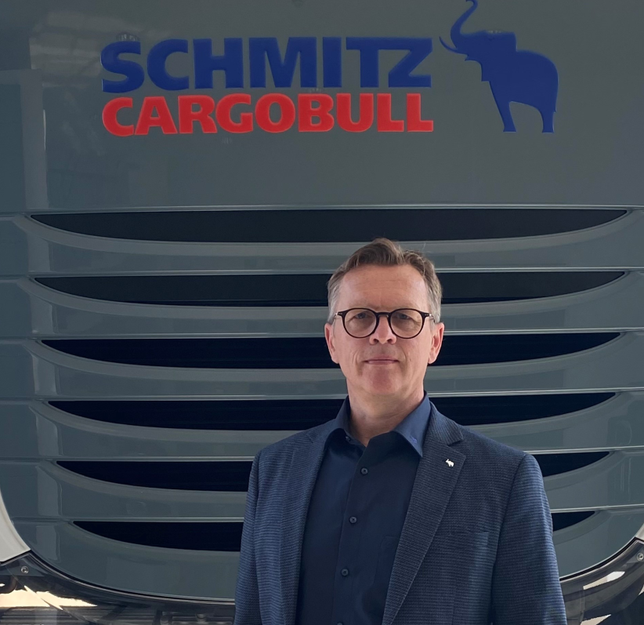
Christian Renfordt is 54 years old, married and has two children.

About Schmitz Cargobull
With an annual production of around 61,000 trailers and with approximately 6,900 employees, Schmitz Cargobull AG is Europe’s leading manufacturer of semi-trailers, trailers and truck bodies for temperature-controlled freight, general cargo and bulk goods. The company achieved sales of around €2.3 billion in the 2021/22 financial year. As a pioneer in the industry, the North German company developed a comprehensive brand strategy early on and consistently established quality standards spanning every level: from research and development, through production and service contracts, to trailer telematics, financing, spare parts, and used vehicles.

The Schmitz Cargobull press team:
Anna Stuhlmeier +49 2558 81-1340 I anna.stuhlmeier@cargobull.com
Andrea Beckonert +49 2558 81-1321 I andrea.beckonert@cargobull.com
Silke Hesener: +49 2558 81-1501 I silke.hesener@cargobull.com

