Press-Information
2025-119

Schmitz Cargobull AG
Schmitz Cargobull strengthens its presence in Central Asia

New subsidiary in Uzbekistan established for greater customer proximity

April 2025 – Schmitz Cargobull is strengthening its presence and customer proximity in Central Asia with the establishment of the subsidiary “Schmitz Cargobull SCA (South Central Asia)” based in Chirchik, near Uzbekistan’s capital Tashkent. By introducing local subsidiaries, the European market leader for semi-trailers is emphasising its commitment to being close to its customers, to optimally meet their needs with tailored products and services.

The opening ceremony for the new site at the local authorised Schmitz Cargobull Service Partner, Technodom, took place at the beginning of April. Ralph Kleideiter, Chief Sales Officer of Schmitz Cargobull, and representatives of the subsidiary presented the new location to invited customers, interested parties and representatives of the press and gave
an outlook on upcoming activities in the region. The dedicated team on site offers direct and individual support for all trailer-related questions. This includes the sale of new and used trailers for refrigerated and fresh food transport, general cargo transport, the construction industry and agriculture, as well as corresponding services such as financing, trailer telematics, service contracts and spare parts supply.

A new Schmitz Cargobull spare parts warehouse with an area of around 300 m² has been set up at the site. The aim is to achieve a turnover of up to €1 million within the first three years. In addition to the spare parts warehouse, sales and presentation areas for new and used vehicles are also available. Furthermore, the service partner network, which currently consists of three service partners throughout Uzbekistan, is continually being expanded.

“The opening of the subsidiary in Uzbekistan brings us another step closer to our customers in the Central Asia region and fulfils our brand promise ‘We are wherever our customers are’. At Schmitz Cargobull, this includes a global production network and direct sales through subsidiaries in almost all European countries, as well as in strategically important markets worldwide. The new location will enable us to meet the needs of transport companies in

2025-120

Uzbekistan and in the neighbouring countries of Turkmenistan and Tajikistan even more effectively,” explained Ralph Kleideiter, Chief Sales Officer of Schmitz Cargobull.

Schmitz Cargobull established a subsidiary in Kazakhstan in 2023 to expand its presence in Central Asia. With the new subsidiary in Uzbekistan, Schmitz Cargobull is emphasising the importance of the STAN countries, which is also reflected in the country's transport growth. According to the National Statistics Committee, the total volume of freight traffic in Uzbekistan reached approximately 1,521.2 million tonnes in 2024, which represents a new record for the last five years. Compared to 2020, when the volume was 1,366.7 million tonnes, this represents an increase of over 11 per cent. Road transport remains the backbone of the logistics system, accounting for 92 per cent of total freight volume. In 2024, road transport companies transported 1.4 billion tonnes of freight.

Address: Uzbekistan, 100077, Tashkent City. Mirzo Ulugbek district, Mirzo Ulugbek Street 25, Atlas Business Tower

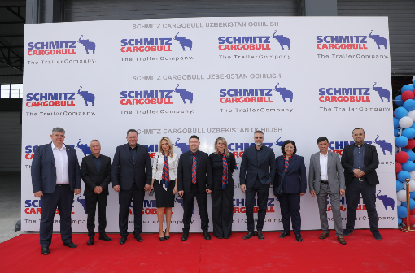
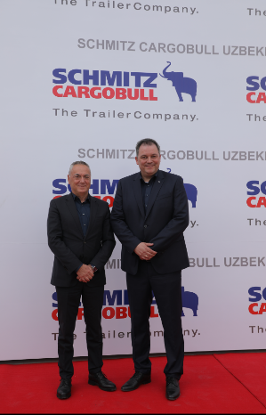
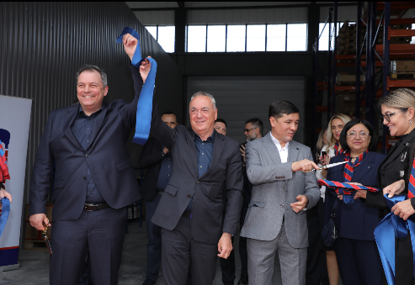
Caption Image 1: The Schmitz Cargobull team is celebrating the opening of the new subsidiary in Uzbekistan: (from left) Ivan Gassov (Aftersales Management KAZ), Mile Mishevski (Sales Director East Europe), Ralph Kleideiter (CSO), Nino Menabde (Sales Support & Administration Georgia), Artem Svintsov (Country Manager Georgia), Marija Mishevska (Sales Support Eastern Europe), Evgenij Sajaz (Regional CFO East-Europe), Sabokhon Kayumova (Sales Director Uzbekistan) and
Rakhimov Nurmukhamad (Founder of Chirchiq Technodom LLC)

Caption Image 2: Ceremonial opening of the subsidiary in Uzbekistan: (from left) Ralph Kleideiter (Chief Sales Officer), Mile Michevski (Sales Director East Europe), Rakhimov Nurmukhamad (Firmengründer Chirchiq Technodom LLC)

Caption Image 3: (from left) Mile Michevski (Sales Director East Europe), Ralph Kleideiter (Chief Sales Officer)

About Schmitz Cargobull
Schmitz Cargobull is the leading manufacturer of semi-trailers for temperature-controlled freight, general cargo and bulk goods in Europe, and a pioneer in digital solutions for trailer services and improved connectivity. The company also manufactures transport cooling units for refrigerated box body semi-trailers for temperature-controlled freight transport. With a comprehensive range of services from financing, spare parts supply, service contracts and telematics solutions to used vehicle trading, Schmitz Cargobull supports its customers in optimising their total cost of ownership (TCO) and digital transformation. Schmitz Cargobull was founded in 1892 in Münsterland, Germany. The family-run company produces around 60,000 vehicles per year with over 6,000 employees and generated a turnover of around €2.4 billion in the 2023/24 financial year. The international production network currently comprises ten plants in Germany, Lithuania, Spain, England, Turkey, Slovakia and Australia.

Press Contact Schmitz Cargobull
Anna Stuhlmeier +49 2558 81-1340 I anna.stuhlmeier@cargobull.com
Andrea Beckonert +49 2558 81-1321 I andrea.beckonert@cargobull.com
Silke Hesener +49 2558 81-1501 I silke.hesener@cargobull.com

