Press-Information
2025-147

Schmitz Cargobull AG

Strategic partnership approved – Schmitz Cargobull takes next step in expansion

GT Trailers and Schmitz Cargobull AG combine their expertise

June 2025 – In March of this year, Schmitz Cargobull, Europe's leading manufacturer of semi-trailers, trailers, and bodies based in Münsterland (Germany), and GT Trailers, a leading manufacturer of high-volume bodies and trailers based in the Opole region of Poland, announced their strategic partnership.

The relevant authorities have now approved the cooperation and Schmitz Cargobull AG's 48 percent stake in GT Trailers. Effective immediately, both companies will combine their strengths and expertise in technology, design, production, and sales of truck bodies and trailers with galvanised chassis.

“At Schmitz Cargobull, we are convinced that cooperation and strategic partnerships are the most important drivers of innovation and growth in our industry,” says Andreas Schmitz, CEO of Schmitz Cargobull. “By working with GT Trailers, our customers will benefit from a broader product portfolio that meets both our requirements for reliability and innovation.”

For high-volume combinations (HVS) and truck bodies (body works), GT Trailers offers an extensive and custom-fit portfolio with individualisation options for every application. Customers can choose between curtainsider and box bodies as well as different equipment lines (Basic, Prestige, 2504). The "Prestige" line features an impressive light-weight frame, floor and body made from aluminum for minimal tare weight, while the "2504" line has a particularly large interior width. In the "Basic" line the customer receives a galvanised steel frame. Application-specific equipment options such as various load securing possibilities, through-loading option, tail lift or forklift mount as well as implementation of individual customer requirements are also part of GT Trailers' range of services.

GT Trailers further offers swap systems, in particular central-axle trailer for swap bodies, swap bodies and swap bodies armaments for trucks in a durable galvanised design.

2025-147

In the semi-trailer segment, the portfolio includes city trailers and single-axle semi-trailers (with a loading volume of up to 98m3 and a payload of over 10,500kg with a permissible gross weight of 16,000kg).

GT Trailers is also active in the development and construction of special vehicles and the project business.
The cooperation will now enable the use of proven Schmitz Cargobull components such as the Schmitz Cargobull axle, FERROPLAST bodies for temperature-controlled transport, and tarpaulin or box bodies for city trailers with steering axles. The two companies will also realise synergy effects in their project business.

Agata Duliniec, CEO of GT Trailers, says: "The cooperation is to the benefit of our customers, as it opens up new opportunities for innovation in our products, services, and market development. We can drive forward our commitment to quality and sustainability in an even more targeted manner and secure our strong market position."

In a next step, GT Trailers customers will also be able to take advantage of Schmitz Cargobull's range of services, such as financing and used vehicle marketing.

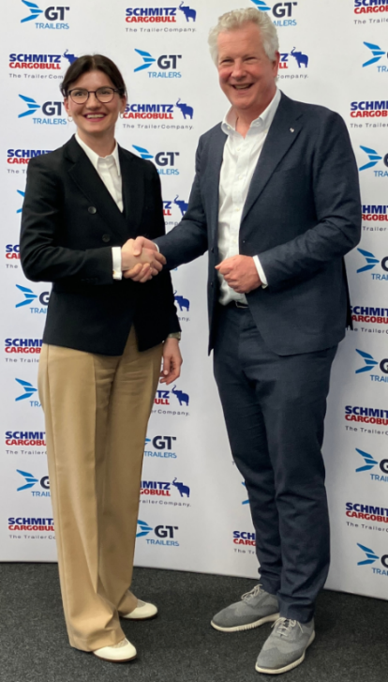

Agata Duliniec, CEO of GT Trailers and Andreas Schmitz, CEO of Schmitz Cargobull AG

2025-147

About Schmitz Cargobull
Schmitz Cargobull is the leading manufacturer of semi-trailers for temperature-controlled freight, general cargo and bulk goods in Europe, and a pioneer in digital solutions for trailer services and improved connectivity. The company also manufactures transport cooling units for refrigerated box body semi-trailers for temperature-controlled freight transport. With a comprehensive range of services from financing, spare parts supply, service contracts and telematics solutions to used vehicle trading, Schmitz Cargobull supports its customers in optimising their total cost of ownership (TCO) and digital transformation.
Schmitz Cargobull was founded in 1892 in Münsterland, Germany. The family-run company produces around 60,000 vehicles per year with over 6,000 employees, and generated a turnover of around €2.4 billion in the 2023/24 financial year. The international production network currently comprises ten plants in Germany, Lithuania, Spain, England, Turkey, Slovakia and Australia.

About GT Trailers:
GT Trailers is a polish manufacturer of high-volume transport solutions, specializing in high-volume sets, BDF swap body systems, and customised vehicle bodies tailored to individual customer needs. The company places a strong emphasis on quality and innovation, utilizing patented technologies and certified materials from renowned suppliers. As a result, GT Trailers’ vehicles stand out with their modern design and high durability, helping customers improve transport efficiency and reduce the total cost of ownership (TCO).
Founded in 1989 in Poland, GT Trailers is a family-owned company with a growing international presence. Its headquarters and production facilities are located in the Opole region, where the company manufactures up to 2,000 vehicles annually for the European market. Through consistent development and a strong focus on customer relationships, GT Trailers strengthens its position as an industry leader by offering transport solutions tailored to individual customer needs, further solidifying its role as a key player in the high-volume transport sector.

Press Contact Schmitz Cargobull
Anna Stuhlmeier +49 2558 81-1340 I anna.stuhlmeier@cargobull.com
Andrea Beckonert +49 2558 81-1321 I andrea.beckonert@cargobull.com
Silke Hesener +49 2558 81-1501 I silke.hesener@cargobull.com

