Press Release
2025-174

Schmitz Cargobull AG
Schmitz Cargobull wins
‘European Transport Award for Sustainability 2026’

With the S.CU d80 ePTO ready transport refrigeration unit, customers can make
the switch to alternative drive systems flexibly, efficiently and with future-proof reliability.

November 2025 – Schmitz Cargobull has once again been awarded the prestigious ‘European Transport Award for Sustainability’ by HUSS-Verlag (Germany). This year, it won in the ‘Cooling and Heating’ category for its S.CU d80 ePTO ready hybrid transport refrigeration unit. The award-winning transport refrigeration unit supports transport companies in their transition to alternative drive systems. The transport refrigeration unit can be operated completely emission-free via the electric power take-off of an electric semi-trailer tractor, while offering maximum operational reliability thanks to the integrated diesel generator. This enables an economical and flexible entry into the decarbonisation of temperature-controlled transport.

"Our customers are faced with the task of making their transport operations more sustainable and at the same time economically viable. This requires solutions such as the S.CU d80 ePTO ready. With this refrigeration unit, we are helping our customers to meet sustainability requirements and keep an eye on their operating costs,” said Ralph Kleideiter, Chief Sales Officer at Schmitz Cargobull, at the award ceremony in Munich on 27 November. “We are delighted that our commitment to practical and economical innovations has been recognised with the European Transport Award for Sustainability," he added.

With the S.CU d80 ePTO ready, Schmitz Cargobull is underlining its role as a pioneer in temperature-controlled transport. The company is the first trailer manufacturer to offer a series-produced diesel-powered transport refrigeration unit that can be operated completely emission-free when used with an electric tractor unit. Schmitz Cargobull thus offers a practical solution for decarbonising temperature-controlled transport.

2025-174

The S.CU d80 ePTO ready is factory-fitted for electric operation. The integrated diesel generator ensures automatic switching between energy sources and guarantees uninterrupted cooling performance – even over long distances or in unpredictable situations. Schmitz Cargobull is thus supporting its customers in an economically viable transition to alternative drive systems, while reducing operating costs through optimised energy efficiency.

About the European Transport Award for Sustainability
The award is presented every two years by an independent commission of experts and honours companies that promote sustainable solutions in the transport and commercial vehicle industry. Schmitz Cargobull has scored several times in recent years, most recently in 2023, with a double victory for the fully electric S.KOe COOL refrigerated trailer and the Full Service Retread Tyres contract.

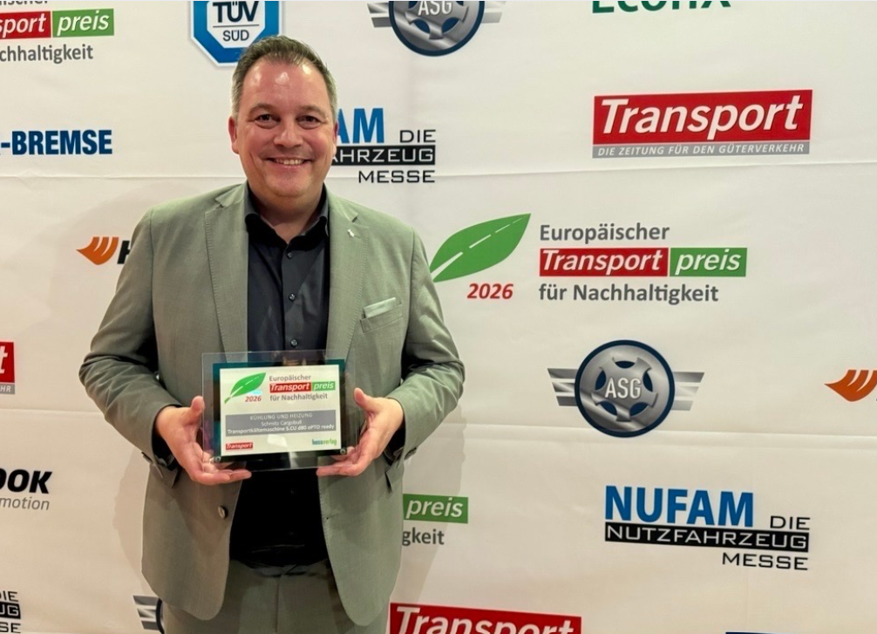
Caption: Ralph Kleideiter, Chief Sales Officer at Schmitz Cargobull, accepted the award at the ceremony in Munich.

About Schmitz Cargobull
Schmitz Cargobull is the leading manufacturer of semi-trailers for temperature-controlled freight, general cargo and bulk goods in Europe, and a pioneer in digital solutions for trailer services and improved connectivity. The company also manufactures transport cooling units for refrigerated box body semi-trailers for temperature-controlled freight transport. With a comprehensive range of services from financing, spare parts supply, service contracts and telematics solutions to used vehicle trading, Schmitz Cargobull supports its customers in optimising their total cost of ownership (TCO) and digital transformation.
Schmitz Cargobull was founded in 1892 in Münsterland, Germany. The family-run company produces around 50,000 vehicles per year with over 6,000 employees and generated a turnover of around €2.16 billion in the financial year 2024/25. Its international production network is made up of factories in Germany, Lithuania, Spain, Turkey and the UK.

The Schmitz Cargobull press team:
Anna Stuhlmeier +49 2558 81-1340 I anna.stuhlmeier@cargobull.com
Andrea Beckonert +49 2558 81-1321 I andrea.beckonert@cargobull.com
Silke Hesener +49 2558 81-1501 I silke.hesener@cargobull.com

