Press Release
2025-163

Schmitz Cargobull AG
Datenfabrik.NRW: How Schmitz Cargobull and CLAAS are bringing digitalisation and AI to the production floor

Skills shortages, high-quality requirements and pressure to produce more efficiently, these challenges are becoming increasingly acute in many industrial companies. For four years, the Datenfabrik.NRW project, led by competence network ‘it’s OWL’, has been working to bring digital, data-driven solutions and artificial intelligence from the test phase into operation. The results now show how digital data models, networked systems and AI are changing everyday production. In total, 51 applications have been developed in the flagship factories of Schmitz Cargobull and CLAAS – from shift planning and digital assistance systems to quality assurance.

The leading-edge network, it’s OWL, implemented the project in collaboration with Schmitz Cargobull, CLAAS, NTT DATA Business Solutions, Duvenbeck Kraftverkehr and MotionMiners, as well as the Fraunhofer Institutes IEM, IML, IOSB-INA and IAIS. With a total value of €14.5 million, including €9.2 million in funding from the state of North Rhine-Westphalia, the data factory is one of the largest initiatives for applied AI in Germany.

“The Datenfabrik.NRW is a beacon for our industrial state of North Rhine-Westphalia. It brings artificial intelligence directly into the factories where value is created. Digitalisation strengthens our small and medium-sized enterprises and makes our business location future-proof and competitive. AI supports employees, makes work safer and more predictable – helping us to combine competitiveness with good, sustainable jobs in our state,” says Mona Neubaur, Minister for Economic Affairs, Industry, Climate Protection and Energy of the State of North Rhine-Westphalia.

Industry under pressure: AI enters everyday life

Schmitz Cargobull and CLAAS draw a positive conclusion.

“With Datenfabrik.NRW, we have created a practical basis for the use of digitalisation and AI in production. The project sets new standards in data-driven production planning and control, while also serving as a blueprint for future smart factory initiatives within our organisation. The positive feedback from industry, research and politics confirms that we are on the right track – not only for Schmitz Cargobull, but also as a source of inspiration for other industrial companies,” emphasises Dr Günter Schweitzer, COO of Schmitz Cargobull. “I am convinced that AI is here to stay.”

“Industry 4.0 is yesterday’s news; data- and AI-supported production is today’s reality. Our premise from the outset was that digitalisation and the use of AI must be worthwhile,” says Jan-Hendrik Mohr, CEO of CLAAS. “We were able to successfully demonstrate this with the project. Through cross-company collaboration in the consortium, we managed to achieve something great together and implement 30 use
cases at CLAAS alone. Projects such as Datenfabrik.NRW are essential for the competitiveness of Germany as an industrial location.”

2025-163

“With the data factory, we are taking AI from the pilot phase into production. It is not only important that solutions work in two flagship factories, but also that methods and structures have been developed that many companies can adopt – that is precisely our mission at it’s OWL,” says Roman Dumitrescu, Managing Director of it’s OWL.

A holistic approach: How Schmitz Cargobull is rethinking digital production planning

In Vreden, Westphalia (Germany), it is clear to see how profoundly digital technologies and artificial intelligence are changing industrial practice. At this site, Schmitz Cargobull is investing over €50 million in expanding its production capacities for refrigerated trailers and box trucks – a clear commitment to the innovative strength of ‘Made in NRW’.

This major project is accompanied by a digital innovation push that is setting new standards. As part of Datenfabrik.NRW, the company has fundamentally rethought the planning process and addressed the challenges of modern manufacturing systems with a holistic digital approach. This sees virtual factory planning, AI-supported analysis and intelligent workplace design seamlessly integrated.

A key result is the creation of a digital factory model as a common database (‘single source of truth’), which enables consistent planning across different tools and creates a common database for all parties involved. This is complemented by AI-supported processing of 3D point clouds from scans that are directly integrated into existing planning systems.

Traditional workplace design is also undergoing a digital transformation: cardboard workshops, in which workplaces are normally recreated using cardboard models, now take place virtually – efficiently, collaboratively and with minimal risk of error. Planning results can, therefore, be validated in digital environments, which speeds up implementation and minimises planning errors. Intuitive layout tools and motion mining technologies – processes that analyse movement data – were also used to analyse and optimise existing workplaces.

“The results impressively demonstrate how digital technologies are transforming industrial value creation – in a practical, scalable and forward-looking way,” says Lukas Ptock, Project Manager of Datenfabrik.NRW at Schmitz Cargobull.

From highlighters to generative AI: CLAAS relies on digital assistance in assembly

Combine harvester production at CLAAS, in Harsewinkel, is characterised by high variability and low quantities. For employees, this means they have to remember a lot of complex work content. Before the project, they were only given paper lists on which
the relevant variants were marked with highlighters. Technical changes had to be manually incorporated into production on a regular basis – a cumbersome process that
was time-consuming and prone to errors. This made it particularly difficult for new employees to get started.
2025-163

In the Datenfabrik.NRW project, CLAAS developed a worker assistance system that initially digitally mapped the sequence of orders, marked them with colours and displayed them via a web-based interface. But that was only the beginning. Step by step, further information was added: product audit data, 3D models, technical changes and assembly instructions are now provided automatically.

The system is directly connected to the factory via an IIoT (Industrial Internet of Things) connection. Driverless transport systems digitally locate their position within the hall and automatically report back orders. This means that employees always see the relevant information at their workplace. Changes are indicated by a traffic light signal and acoustic signals, helping to keep errors to a minimum.

“In this use case, we are guided by the well-known 6Rs from logistics: the right information, at the right time, in the right quantity, in the right quality, in the right place and with the right effort. It is important not to overwhelm anyone with information, but to provide targeted support,” says Timo Westerbusch, Project Manager for Data-Driven Manufacturing at CLAAS.

The system was designed to be scalable from the outset. Today, it is already in use at 120 workstations in Harsewinkel, and an international roll-out is in preparation.

The topic of artificial intelligence is not being left out either. At the same time, CLAAS is testing the integration of a chatbot based on generative AI, a technology that can generate language independently. In future, this assistant will provide assembly information as needed. Initial tests, such as the automated provision of warning stickers, are proving promising.

“It is important to us that all information displayed in our system is reliable. If an error occurs due to incorrect data, it can happen that acceptance of the system is lost. That’s why we place particular emphasis on intensive testing of our results before integrating them into the productive environment,” adds Westerbusch.

51 applications, one lesson: AI must not remain a pilot project

The data factory has shown that AI applications do not have to remain in the experimental stage, they can also be implemented. This is shown by the 51 use cases in real factories and a clear process model for transfer turn individual projects into recurring solutions that can also be transferred to other companies.

Impact beyond the locations

The AI.NRW competence platform also emphasises the importance of this strategy.
“At Datenfabrik.NRW, AI systems are used directly in factory planning, production, logistics and corporate architecture. The partners show that AI is not a pipe dream, but already a
great help to companies today. In the project, we see a strong transfer from research to application,” says Dr Christian Temath, Managing Director of KI.NRW.

KI.NRW has included Datenfabrik.NRW in its flagship initiative, supported the visualisation of the project results and networked project staff with AI experts from other fields. KI.NRW

2025-163

flagships are highly innovative and application-oriented AI projects in individual and joint ventures from various industries, such as trade, production, crafts and health.

From the lighthouse to the masses: How it's OWL reaches small and medium-sized enterprises

In future, it’s OWL will ensure that the approaches developed do not remain in the pilot plants, but become usable for SMEs in North Rhine-Westphalia and beyond. Together with the partners involved, the Artificial Intelligence Technology Network is bringing the concept from the drawing board to the factory floor. Companies can draw on tried-and-tested methods and tools instead of starting from scratch.

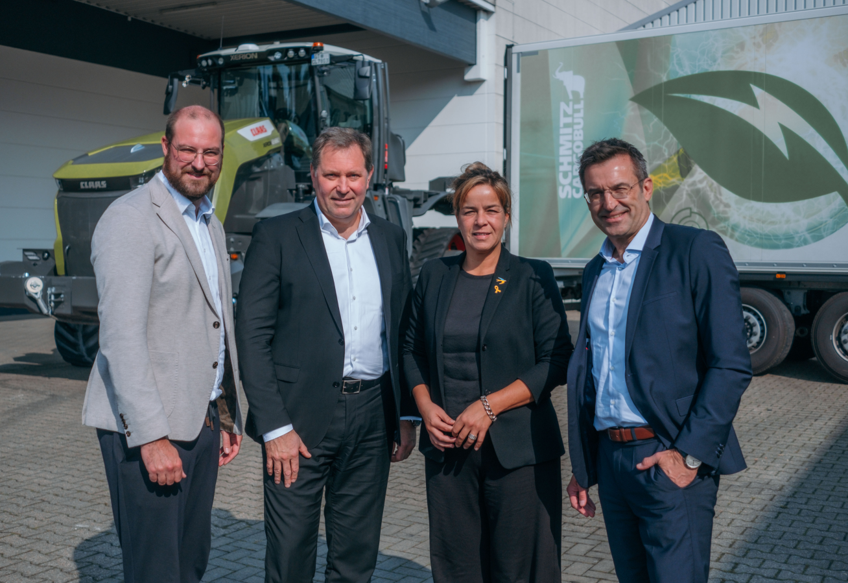
Caption:
From left: Dr Arno Kühn (Head of Strategy, R&D, Extended Management Board, it's OWL), Jan-Hendrik Mohr (CEO, CLAAS), Mona Neubaur (Minister for Economic Affairs, Industry, Climate Protection and Energy, North Rhine-Westphalia), Dr Günther Schweitzer (COO, Schmitz Cargobull)

Photo credit: it's OWL

About Schmitz Cargobull
Schmitz Cargobull is the leading manufacturer of semi-trailers for temperature-controlled freight, general cargo and bulk goods in Europe, and a pioneer in digital solutions for trailer services and improved connectivity. The company also manufactures transport cooling units for refrigerated box body semi-trailers for temperature-controlled freight transport. With a comprehensive range of services from financing, spare parts supply, service contracts and telematics solutions to used vehicle trading, Schmitz Cargobull supports its customers in optimising their total cost of ownership (TCO) and digital transformation.
Schmitz Cargobull was founded in 1892 in Münsterland, Germany. The family-run company produces around 50,000 vehicles per year with over 6,000 employees, and generated a turnover of around €2.16 billion in the financial year 2024/25. Its international production network is made up of factories in Germany, Lithuania, Spain, Turkey and the UK.

The Schmitz Cargobull press team:
Anna Stuhlmeier +49 2558 81-1340 I anna.stuhlmeier@cargobull.com
Andrea Beckonert +49 2558 81-1321 I andrea.beckonert@cargobull.com
Silke Hesener +49 2558 81-1501 I silke.hesener@cargobull.com

