**Press Release**

**2025-140**

Schmitz Cargobull AG

**2025 elogistics award: Schmitz Cargobull honoured for digital transformation in the logistics sector**

**The award was presented at the 40th annual AKJ Automotive network conference “RESTART AUTOMOTIVE 2025”**

May 2025 – Schmitz Cargobull has been honoured with the 2025 elogistics award at the 40th annual AKJ Automotive network conference “RESTART AUTOMOTIVE 2025”. During the evening’s festivities, which were held at Congresshalle Saarbrücken in south Germany, Jürgen Barke – Saarland’s State Minister of Economics, Innovation, Digitalisation and Energy – and members of the jury presented the prize to Christopher Coenen. Coenen is Schmitz Cargobull’s Head of Group Logistics and representative for its digitalisation team. The ceremony also included a panel discussion between industry experts, who discussed the challenges facing digital transformation within the automotive sector.

The experts from Schmitz Cargobull were recognised for their solution “Integrated process landscape for managing volatile supply chains in an adaptive production network”. This comprehensive digitalisation initiative enables decentralised, flexible, and sustainable management of logistics operations.

“We are so pleased to have received this award. We see it as a joint achievement, shared by the members of our cross-site logistics teams, IT and external partners. The goal of our initiative is to make production and logistics processes within a global and dynamic supply chain environment more robust, adaptable and efficient. The award-winning solution is based around the core components of decentralised transport management with end-to-end data flows, digital yard management, and process-based, integrated reusable container management with global inventories that are updated on a daily basis,” says Coenen.

**2025-140**

Schmitz Cargobull’s digitalisation partner Heylog was also honoured for its contribution to the solution. As part of the digitalisation of yard management, Heylog’s platform will be responsible for key tasks such as digital

driver registration, safety training, arrivals management and the directing of incoming material deliveries. Rather than relying on complex hardware, Heylog’s approach leverages existing technology, such as smartphones, QR codes and messaging services like WhatsApp, and integrates those seamlessly with established software solutions like SAP. “Thanks to Heylog, we can bridge the digital gap between delivery and unloading, significantly reduce waiting times and enhance process efficiency for the long term,” explains Coenen.

According to the jury – comprising esteemed leaders from the automotive industry, digitalisation experts and professors from Saarland University of Applied Sciences – Schmitz Cargobull’s solution was an impressive demonstration of how digitalisation can be used to increase operating agility and boost economic sustainability. Praise went to the solution’s modular architecture and the ongoing focus on practical requirements.

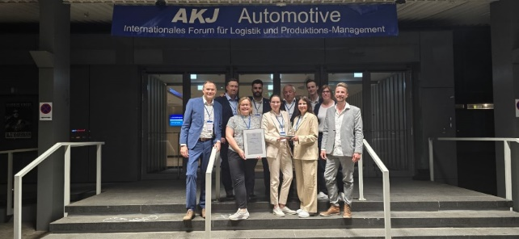

Caption: Christopher Coenen (left) and his team were delighted to receive the 2025 elogistics award

**About Schmitz Cargobull**

Schmitz Cargobull is the leading manufacturer of semi-trailers for temperature-controlled freight, general cargo and bulk goods in Europe, and a pioneer in digital solutions for trailer services and improved connectivity. The company also manufactures transport cooling units for refrigerated box body semi-trailers for temperature-controlled freight transport. With a comprehensive range of services from financing, spare parts supply, service contracts and telematics solutions to used vehicle trading, Schmitz Cargobull supports its customers in optimising their total cost of ownership (TCO) and digital transformation. Schmitz Cargobull was founded in 1892 in Münsterland, Germany. The family-run company produces around 60,000 vehicles per year with over 6,000 employees and generated a turnover of around €2.4 billion in the 2023/24 financial year. The international production network currently comprises ten plants in Germany, Lithuania, Spain, England, Turkey, Slovakia and Australia.

**The Schmitz Cargobull press team:**

Anna Stuhlmeier +49 2558 81-1340 I [anna.stuhlmeier@cargobull.com](mailto:anna.stuhlmeier@cargobull.com)

Andrea Beckonert +49 2558 81-1321 I [andrea.beckonert@cargobull.com](mailto:andrea.beckonert@cargobull.com)  
Silke Hesener +49 2558 81-1501 I [silke.hesener@cargobull.com](mailto:silke.hesener@cargobull.com)