Press release
2020-506

Schmitz Cargobull AG
Comfortable and safe loading with the Schmitz Cargobull M.KO/Z.KO deep-freeze truck body and trailer combination

pfenning logistics relies on Schmitz Cargobull’s through-loading truck body and trailer combination

December 2020 - The M.KO COOL deep-freeze truck body and trailer combination and the Z.KO COOL deep-freeze central axle trailer have also completed their transition to the new generation. The engineers focused on increased insulation for even safer transport, weight reduction for greater payload, safe and easy handling for enhanced ergonomics and higher time savings, as well as efficient through-loading.

The optimised deep-freeze truck body and trailer combination also won over pfenning logistics. “This vehicle enables our drivers to load both deep-freeze box bodies at once. The trailer no longer has to be uncoupled during the process, and the entire truck and trailer combination only has to be driven up to the ramp once. That truly saves time,” explains Manuel Pfenning, Managing Director of the pfenning logistics group. With approximately 3,700 employees at 90 locations and a fleet of more than 800 trucks, pfenning logistics numbers among Germany’s topfull-service logistics providers. The multifunction floor in the body enables quick and easy load securing. The new partition wall in the bodies for multi-temperature transport is another clever solution. It can be divided 1/3 to 2/3, is longitudinally adjustable and can be repaired quickly without disassembly. This feature enables frozen and fresh products to be loaded and transported in the same body.

Thicker side walls, bulkhead and floor with unchanged internal dimensions have improved the insulation properties. In addition,, depending on the specifications, the M.KO COOL’s body meets the demanding requirements of ATP/FRC certification for perishable foodstuffs. The M.KO weighs up to 60 kg less thanks to its optimised design, enabling a higher payload. Just like the S.KO COOL box body semi-trailer, the M.KO COOL can also be equipped with the multifunction floor for simplified load securing. With its high-quality workmanship, the multifunction floor provides excellent slip resistance, a longer service life and an integrated load securing structure.

2020-506

Furthermore, the trailer features a new bumper design to protect the trailers during loading and unloading via the ramp. The body includes the same design and quality features as the refrigerated semi-trailer. Robust steel profiles and new door handles round out the visual appearance.
If the M.KO COOL refrigerated truck body is coupled with the Z.KO COOL central axle trailer, the combination can be used as a through-loading trailer. This enables the driver to load and unload the M.KO using a forklift directly through the Z.KO. This saves time and space as the high-volume truck body and trailer combination only needs to drive up to the ramp once and there is no need to unhitch the trailer.
In the through-loading combination, the front door of the Z.KO can also serve as a pneumatic flap, providing protection against the weather during loading and unloading. The front flap of the Z.KO is extended out over the rear lifting and roll-over plate when loading the M.KO and Z.KO. This enables the front flap to act as a roof, and protects the open area between the vehicles from rainwater. The pull rod with pneumatic locking is extendable and can be controlled from the driver’s cab.

The Schmitz Cargobull transverse partition provides the trailer with a flexible option for MultiTemp transport, ensuring reliable cooling in all of the chambers. The partition wall is designed for 1/3 and 2/3 division of the body and is based on the proven FERROPLAST ThermoTechnology. This offers maximum insulation not only in the body but also for the partition wall. To ensure quick and easy repairs such as when replacing the gas pressure springs in the trailer, there is no need to remove the partition wall. The partition wall can be moved longitudinally, folded up to the roof and can also be used at the end of the body.
Further advantages include the proven stainless steel balancing unit, recessed handles, the high-quality and durable rubber seal as well as simple and back-friendly usage. The Schmitz Cargobull partition walls can be ordered individually or together for bodies with any length longitudinal partition, depending on the customer requirements.

2020-506

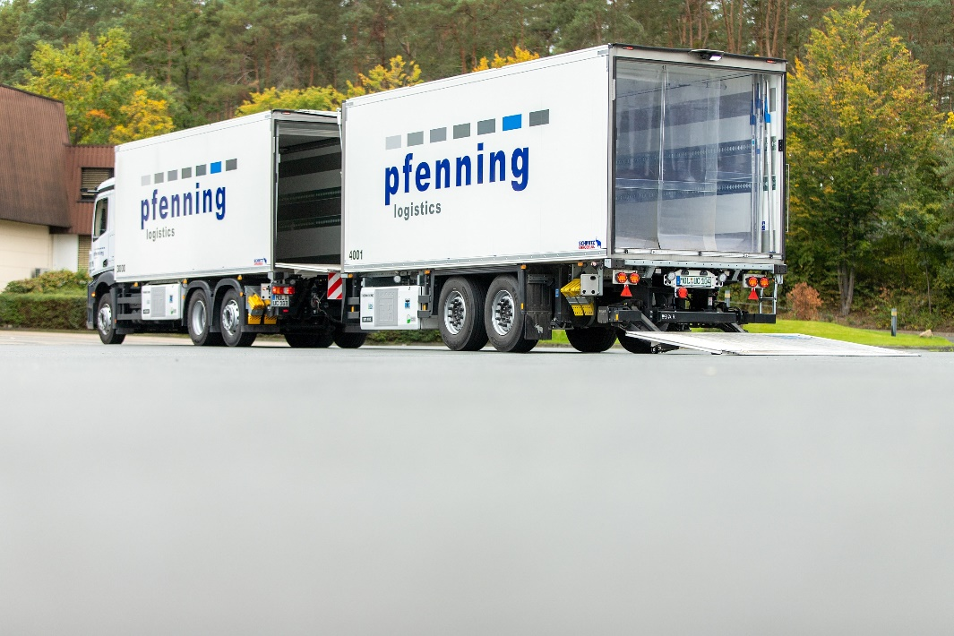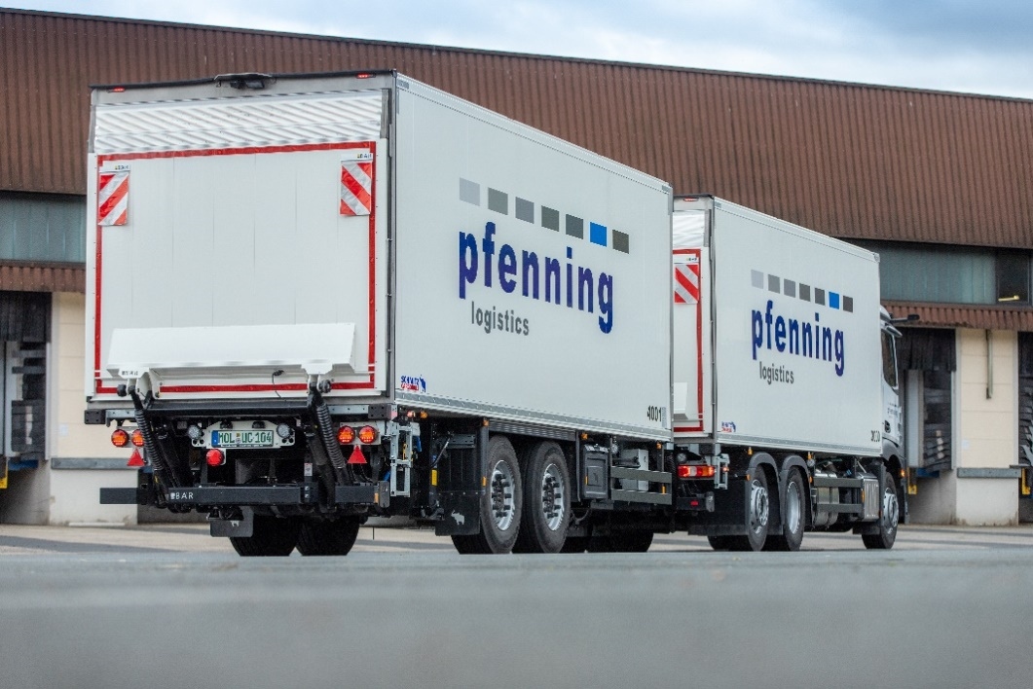
About pfenning logistics group:

pfenning logistics group is a contract logistics service provider offering a full range of services for German medium-sized businesses, managed by the third and fourth generations of the Pfenning family. The company has 3,700 employees across 90 locations in Germany, and its headquarters are in Heddesheim, Baden-Württemberg. Known as a contract logistics provider, the group has successively expanded its product portfolio in recent years. Today, the group includes a nationwide personnel provider and a car dealership group that equips and oversees company fleets with passenger and commercial vehicles. In addition, the service group also offers a broad spectrum of value-added services for industrial and commercial companies – ranging from plant security and metal construction to real estate development.
Competent and reliable, the company provides full-service supply chain services, which are mirrored in a proprietary network structure. With a fleet of 800 trucks and a total storage area of 500,000 m², the company provides the strong backbone for its customers’ logistics and ranked 55th out of 60,000 logistics service providers in Germany in the “Top 100 of Logistics” study. The company provides solutions that safeguard stable enterprise resource circuits, guarantee an excellent price-performance ratio and pave the way for market success.
In the extremely dynamic retail logistics market, pfenning logistics numbers among Germany’s leading service providers. Other industries also rely on the expertise of the Heddesheim-based company: Special warehouses have been constructed

2020-506

and commissioned for the chemical, automotive, food, and pharmaceutical industries. These meet the highest safety and hygiene standards and are certified accordingly.
Four decades of experience form the foundation for ground-breaking real estate projects. In collaboration with multicube rhein-neckar, pfenning logistics developed an innovative, multi-user concept in 2012 that has since gone on to win multiple awards and create opportunities for individual usage and sustainable standards. This success story has continued with the multicube rheinhessen since 2018. Both logistics centres are among Europe’s top 10 new industrial buildings to be certified DGNB Platinum. The multicube rhein-neckar has remained the undefeated No. 1 since 2012, while the multicube rheinhessen is in 9th place.
Almost 90 years of experience support the outstanding solution expertise that pfenning logistics offers its customers – from the smallest to the largest scale.
Further information is available at

www.pfenning-logistics.com
www.multicube.org
www.lkw-logenplatz.de

About Schmitz Cargobull
With an annual production of around 46,100 trailers and with around 5,700 employees, Schmitz Cargobull AG is Europe’s leading manufacturer of semi-trailers, trailers and truck bodies for temperature-controlled freight, general cargo and bulk goods. The company achieved sales of approximately €1.87 billion in the 2019/2020 financial year. As a pioneer in the industry, the North German company developed a comprehensive brand strategy early on and consistently established quality standards spanning every level: from research and development, through production and service contracts, to trailer telematics, financing, spare parts, and used vehicles.

The Schmitz Cargobull press team:
Anna Stuhlmeier +49 2558 81-1340 I anna.stuhlmeier@cargobull.com
Andrea Beckonert +49 2558 81-1321 I andrea.beckonert@cargobull.com
Silke Hesener: +49 2558 81-1501 I sike.hesener@cargobull.com

