Press Release
2024-117

Schmitz Cargobull AG

Requirements Engineering at Schmitz Cargobull certified with IREB silver status once again

April 2024 - Requirements Engineering, a specialist department in Schmitz Cargobull's Electrical/Electronic (E/E) Systems Engineering, has been awarded silver status by the IREB (International Requirements Engineering Board) for 2024 – the second year in a row it has achieved this recognition.
This award recognises the high qualification of employees in the field of requirements engineering. It confirms the professional determination, communication, validation and organisation of market and vehicle requirements, in order to offer customers high-quality and effective added value.
Requirements engineering is a crucial part of the development processes at Schmitz Cargobull. From conception to series production, the team works closely with product management and product architecture to ensure that the vehicles deliver efficient and reliable added value to the customer. Strategic requirements are transformed into stakeholder, system and subsystem requirements in order to optimally implement the needs of the market and vehicle development.
In recent years, Schmitz Cargobull has strengthened its technological expertise and continuously expanded its E/E division in order to meet the growing demands of the transport and logistics market with high-quality and future-oriented solutions.
As a system developer and provider, Schmitz Cargobull can offer its customers comprehensive solutions from a single source, including digital services, automated vehicle handling and innovative products such as the all-electric reefer semi-trailer
S.KOe COOL.

2024-117
The IREB (International Requirements Engineering Board) is a non-profit organisation and the developer of the CPRE (Certified Professional for Requirements Engineering) certification model for employees in the fields of requirements engineering, business analysis or software and systems development.
The board members are independent and internationally recognised experts from industry, consulting, research and education. Schmitz Cargobull was awarded silver status in 2023 and now again for the year 2024. This status is monitored by the IREB through certification audits and is repeated annually. Achieving Gold status is the next goal of the Schmitz Cargobull requirements engineering team.
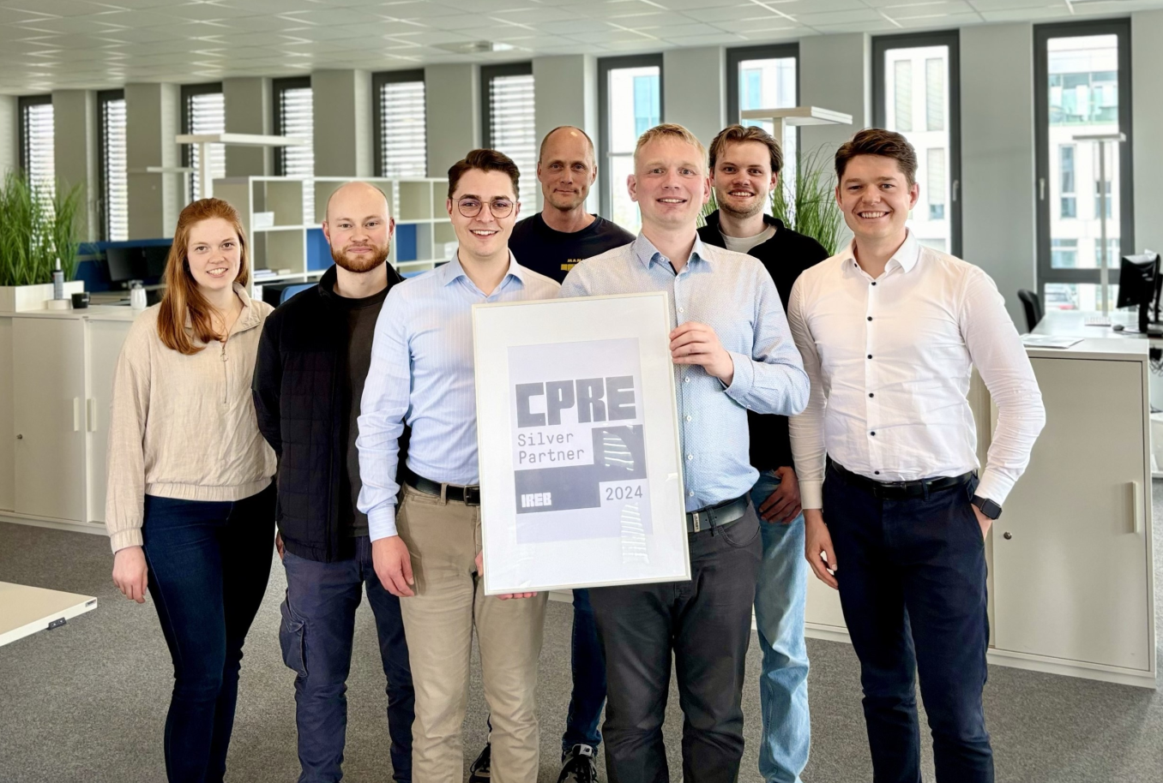

Caption (f.l.): Anna Fißmann, Philipp Fremann, Fabian van den Boom, Thorsten Berg, Bernd Weyring (Head of Requirements Engineering), Leander Buyting, Maximilian Kemper

About Schmitz Cargobull
Schmitz Cargobull is the leading manufacturer of semi-trailers for temperature-controlled freight, general cargo and bulk goods in Europe and a pioneer in digital solutions for trailer services and improved connectivity. The company also manufactures transport refrigeration machines for refrigerated semi-trailers for temperature-controlled freight transport. With a comprehensive range of services from financing, spare parts supply, service contracts and telematics solutions to used vehicle trading, Schmitz Cargobull supports its customers in optimising their total cost of ownership (TCO) and digital transformation. Schmitz Cargobull was founded in 1892 in Münsterland, Germany. The family-run company produces
around 60,000 vehicles per year with over 6,000 employees and generated a turnover of around 2.6 billion euros in the 2022/23 financial year. The international production network currently comprises ten plants in Germany, Lithuania, Spain, England, Turkey, Slovakia and Australia.

The Schmitz Cargobull press team:
Anna Stuhlmeier +49 2558 81-1340 I anna.stuhlmeier@cargobull.com
Andrea Beckonert +49 2558 81-1321 I andrea.beckonert@cargobull.com
Silke Hesener +49 2558 81-1501 I silke.hesener@cargobull.com

