Press Release
2025-159

Schmitz Cargobull AG
Schmitz Cargobull publishes its third sustainability report – aligned with ESRS for the first time
Sustainability as a guiding strategic principle – advances in climate change mitigation, resource conservation and social responsibility

October 2025 – Schmitz Cargobull AG, the international family-run company and Europe’s leading semi-trailer manufacturer, has published its third voluntary sustainability report. For the first time, the European Sustainability Reporting Standards (ESRS) have been used as the basis for the report, which documents the company’s progress in the fields of climate change mitigation, resource management, circular economy, social responsibility, and responsible corporate governance.

The sustainability strategy is firmly anchored in the company’s Strategy 2030 and underlines Schmitz Cargobull’s long-term commitment to the sustainable transformation of the transport and logistics sector. In its strategy, the company is following a holistic approach, giving equal consideration to economic, ecological, and social aspects. One of the central goals is to reduce the environmental footprint across the entire value creation chain – from product development and production through to the customer usage phase and product end-of-life.

One major milestone has been the validation of the net-zero targets by the Science Based Targets initiative (SBTi). In these targets, Schmitz Cargobull commits itself to a 90% decrease in greenhouse gas emissions across all relevant Scopes by 2045 – in accordance with the SBTi Net-Zero Standard.*

“Over the past two years, we have made significant strides when it comes to the sustainability of our business, demonstrating that we are taking responsibility,” explains Dr Günter Schweitzer, Chief Operations Officer at Schmitz Cargobull and the lead manager responsible for the company’s sustainability strategy. Schweitzer adds: “In this process, it is essential that sustainable measures are both practical and impactful across the entire

2025-159

value chain. In other words, they need to offer ecological and economical benefits. Market economy instruments, such as carbon pricing instead of disincentives through subsidisation, provide effective momentum in this regard. At the same time, we are aware of the challenges associated with these efforts. We are only able to conduct business sustainably and remain competitive in the long term when climate change mitigation and economic success are not in conflict with one another and when sustainability is not smothered by bureaucracy.”

Concrete achievements at a glance:
- Emissions: reduction of Scope 1 and Scope 2 greenhouse gas emissions by 70% since the 2021/22 financial year.
- Waste management: volume of mixed waste halved at all sites compared to the 2021/22 financial year.
- Renewable energy: installation of solar panels with a total output of 725 kWp; additional panels for 1,500 kWp currently in planning.
- Environmental management: all large production sites are certified in accordance with ISO 14001.

Schmitz Cargobull is also investing in innovations that offer sustainable added value in its product portfolio. The all-electric S.KOe COOL refrigerated box body semi-trailer enables cooled goods to be transported with zero emissions. The S.CU d80 ePTO ready – which was showcased at the 2024 IAA – can be powered solely by electricity via a high-voltage battery in an eHGV: another step towards climate-friendly logistics solutions.

Download for the 2024/25 sustainability report
The third voluntary sustainability report, prepared in accordance with ESRS, can now be downloaded from the Schmitz Cargobull website:
https://schmitz.cargobull.com/sustainability-as-a-viable-path-for-the-future

Click here to go directly to the sustainability report: https://schmitz.cargobull.com/sustainability-report-2024-2025

*For SBTi-compliant formulations of the company’s short- and long-term climate targets, please see page 20 of the 2024/25 Schmitz Cargobull sustainability report

2025-159

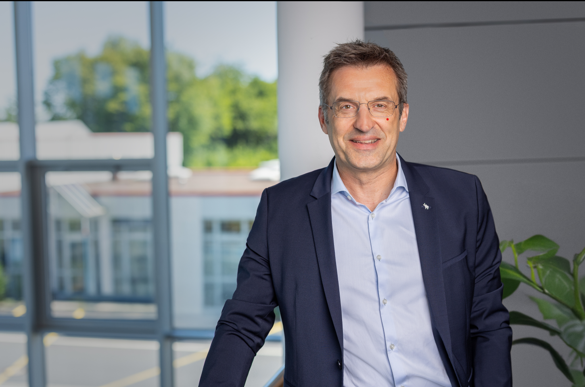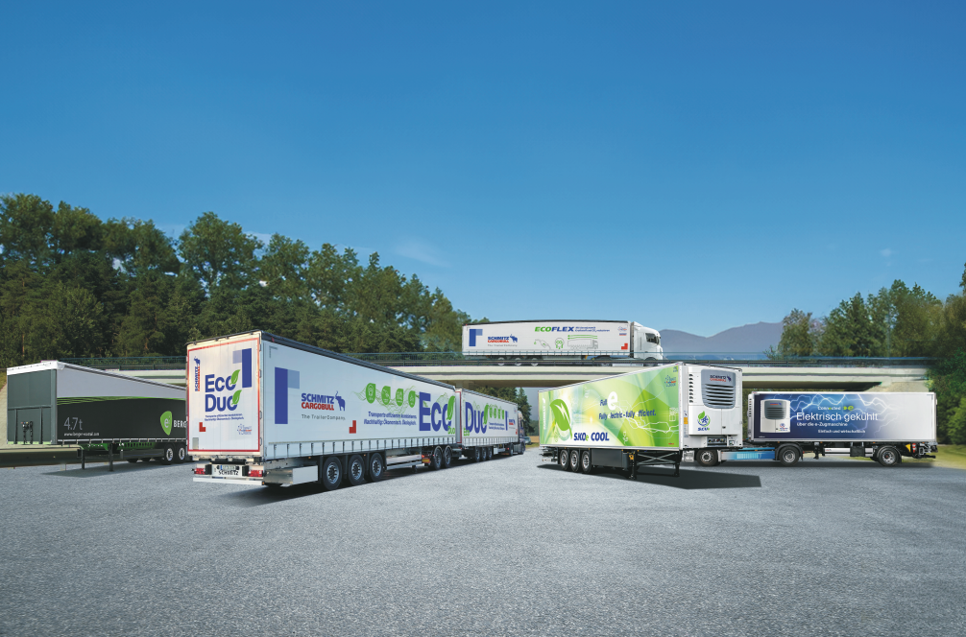
Dr. Günter Schweitzer – Chief Operations Officer Schmitz Cargobull Ecoportfolio
and senior manager responsible for the sustainability
strategy at Schmitz Cargobull

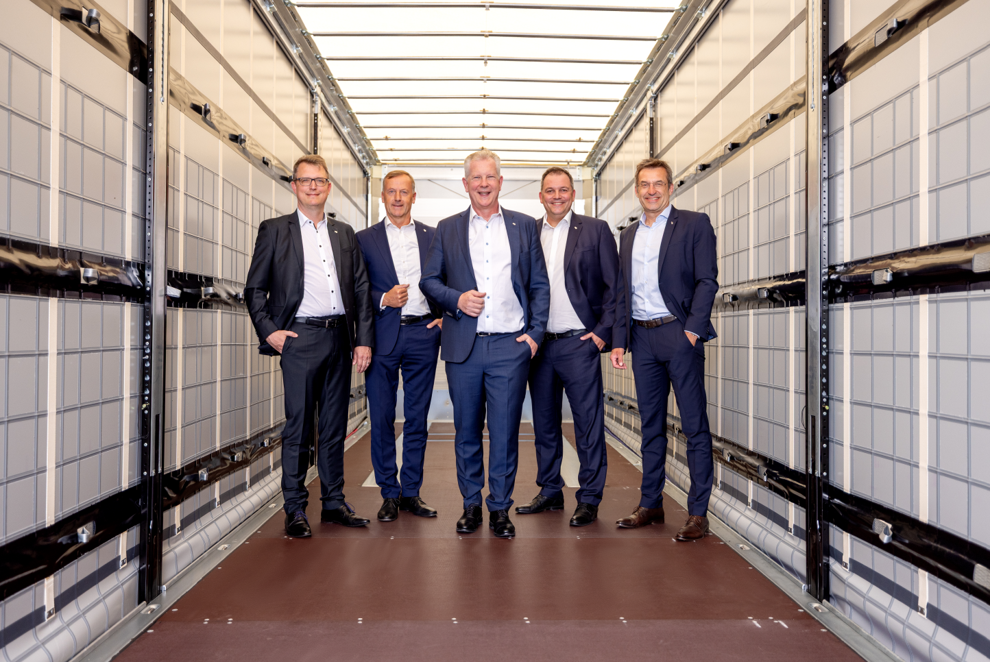
The Management Board at Schmitz Cargobull AG
Marnix Lannoije – Chief Technical Officer, Andreas Busacker – Chief Financial Officer, Andreas Schmitz – Chief Executive Officer, Ralph Kleideiter – Chief Sales Officer, Dr. Günter Schweitzer – Chief Operations Officer (from left)

About Schmitz Cargobull
Schmitz Cargobull is the leading manufacturer of semi-trailers for temperature-controlled freight, general cargo and bulk goods in Europe, and a pioneer in digital solutions for trailer services and improved connectivity. The company also manufactures transport cooling units for refrigerated box body semi-trailers for temperature-controlled freight transport. With a comprehensive range of services from financing, spare parts supply, service contracts and telematics solutions to used vehicle trading, Schmitz Cargobull supports its customers in optimising their total cost of ownership (TCO) and digital transformation.
Schmitz Cargobull was founded in 1892 in Münsterland, Germany. The family-run company produces around 50,000 vehicles per year with over 6,000 employees, and generated a turnover of around €2.16 billion in the financial year 2024/25. Its international production network is made up of factories in Germany, Lithuania, Spain, the UK and the Republic of Türkiye.

The Schmitz Cargobull press team:
Anna Stuhlmeier +49 2558 81-1340 I anna.stuhlmeier@cargobull.com
Andrea Beckonert +49 2558 81-1321 I andrea.beckonert@cargobull.com
Silke Hesener +49 2558 81-1501 I silke.hesener@cargobull.com

