Press Release
2026-111

Schmitz Cargobull AG
Schmitz Cargobull begins operations at new production plant in Romania
The new plant in Oradea will assemble S.CS curtainsider semi-trailers and S.KI tipper semi-trailers for the Central European market

March 2026 – Schmitz Cargobull is expanding its production network and strengthening its presence in the strategically important and dynamically growing markets of Central Europe with a new assembly plant in Oradea, Romania. Assembly of the S.CS curtainsiders began in January 2026, with production of the S.KI tipper semi-trailer tippers to follow in spring 2026. The new location in Romania complements the existing production network with plants in Germany, Lithuania, Spain, UK, and Turkey.

Andreas Schmitz, CEO of Schmitz Cargobull AG, says:
"With the new location, we are closing a strategic gap in our international production network and strengthening our proximity to transport companies in Central Europe. Our goal is to support them with reliable and innovative transport solutions that create lasting, concrete added value. This includes high-quality vehicles, short delivery times, a powerful 24/7 spare parts supply, and a comprehensive range of services – from financing and trailer telematics solutions to used vehicle sales."
Strong market position*
With a market share of 25 percent in Europe, Schmitz Cargobull is one of the leading manufacturers of semi-trailers, and is the market leader in the curtainsider S.CS, refrigerated semi-trailers S.KO COOL, tipper semi-trailers S.KI, and dry freight semi-trailers S.BO segments.

The company is firmly established in the Central European market, where it has a market share of 31 percent. In Romania, Schmitz Cargobull is the market leader in the curtainsider, refrigerated, and tipper trailer segments with its product portfolio.
Through its Romanian subsidiary Schmitz Cargobull Romania, the company has already delivered more than 50,000 trailers – clear evidence of customer confidence.

2026-111

An efficient spare parts distribution system and a network of around 30 authorized service partners ensure short response times and high vehicle availability.

Investments and capacities at the new location
Schmitz Cargobull has invested around €3.5m in the new assembly plant. With a production area of 6,000 m², up to 80 units can be manufactured per week in single-shift operation. In addition, an outdoor area of up to 45,000 m² is available. The new location currently employs 25 qualified specialists who ensure efficient processes and implement optimally integrated solutions for customers and partners. The location in Romania is to be further expanded in the coming years.

*Figures for financial year 2024/25

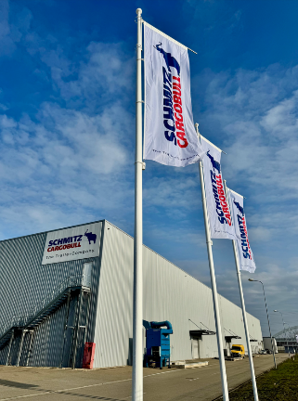

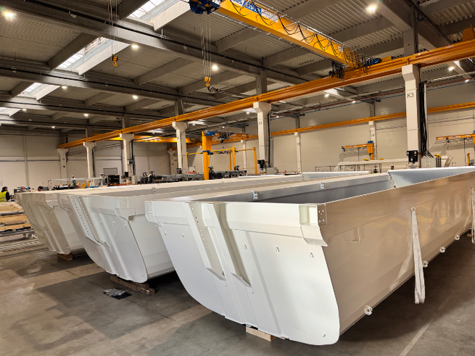
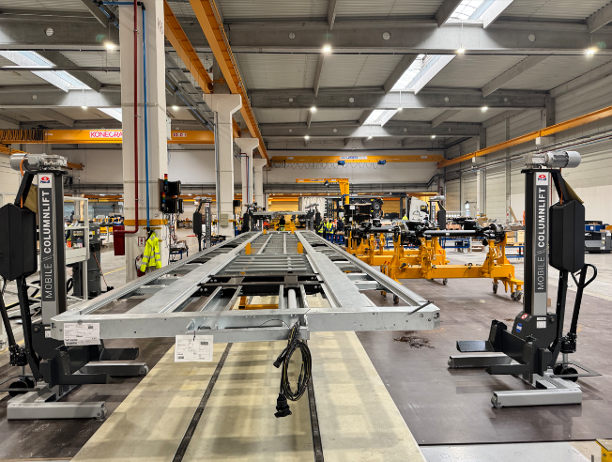
Andreas Schmitz, CEO Schmitz Cargobull

2026-111

About Schmitz Cargobull
Schmitz Cargobull is the leading manufacturer of semi-trailers for temperature-controlled freight, general cargo and bulk goods in Europe, and a pioneer in digital solutions for trailer services and improved connectivity. The company also manufactures transport cooling units for refrigerated box body semi-trailers for temperature-controlled freight transport. With a comprehensive range of services from financing, spare parts supply, service contracts and telematics solutions to used vehicle trading, Schmitz Cargobull supports its customers in optimising their total cost of ownership (TCO) and digital transformation.
Schmitz Cargobull was founded in 1892 in Münsterland, Germany. The family-run company produces around 50,000 vehicles per year with over 6,000 employees and generated a turnover of around €2.16 billion in the financial year 2024/25. Its international production network is made up of factories in Germany, Lithuania, Spain, Turkey, Romania and the UK.

The Schmitz Cargobull press team:
Anna Stuhlmeier +49 2558 81-1340 I anna.stuhlmeier@cargobull.com
Andrea Beckonert +49 2558 81-1321 I andrea.beckonert@cargobull.com
Silke Hesener +49 2558 81-1501 I silke.hesener@cargobull.com

