Press Release
2023-105

Schmitz Cargobull AG
Used trailers from Schmitz Cargobull are ranked
No. 1 in demand
Europa-LKW.de publishes survey for the 2022 used truck and trailer market

January 2023 - Schmitz Cargobull has ranked highly in a new study of the used truck and trailer market in 2022 published by Europa-LKW.de, an online platform for used vehicles.

Based on user analysis, the platform determines which used vehicles were most in demand in Germany in 2022. In the search for semi-trailers, Schmitz Cargobull is in first place in the rating for all trailer types - and the most searched trailer brand.

This top rating shows that Schmitz Cargobull is also the preferred partner for customers seeking used vehicles. It produces high-quality, durable and sustainable trailers and semi-trailers.
Schmitz Cargobull emphasises longevity in its product strategy and is committed to the circular economy in order to extend the life cycle of its vehicles.
One example is the galvanised chassis. Galvanisation increases the service life of the chassis by up to five years compared to a coated chassis. This has a positive effect on the entire service life and on the resale value.

Schmitz Cargobull sells its used vehicles in over 38 depots - Cargobull Trailer Stores - throughout Europe. At these depots, over 10,000 used vehicles are sold to some
70 countries every year. Around 90% of these vehicles come from Schmitz Cargobull. Particularly in the markets of Western, Central and South-Western Europe, Cargobull
Trailer Stores are experiencing strong demand - especially for young used vehicles.

In the depots customers will find an extensive range of around 1,600 used vehicles from different manufacturers. Vehicles that meet the strict quality standards of the used vehicle experts are awarded the "Trailer^{plus}" seal. If a vehicle has this seal, it has been subjected to
a thorough quality check by the independent testing company before delivery, with the body, technology and chassis being put "through their paces".

2023-105

As even the best trailer can break down, a free breakdown cover contract is available for the first 12 months with the Trailer^{plus} vehicle. This means that the customer will receive rapid assistance from Schmitz Cargobull Euroservice in the event of a breakdown. The contract includes payment of all labour costs, material costs in the event of damage to the trailer, all travel costs, and a payment guarantee.
Other established Schmitz Cargobull service offers, such as tailor-made financing options, are also available for used trailers.

You can find all the used vehicles from the Cargobull Trailer Store online at
www.trailer-store.com

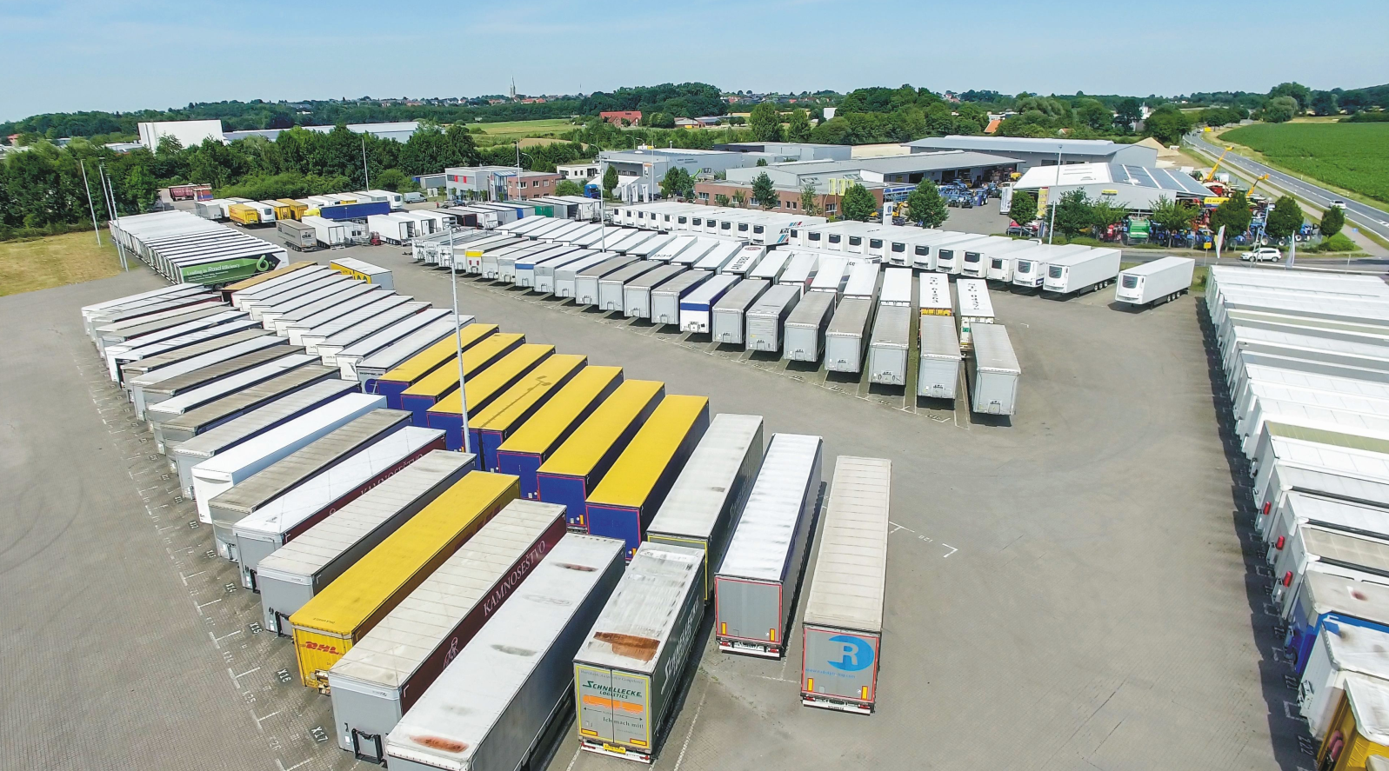
Cargobull Trailer Store, Headquarter Altenberge

About Schmitz Cargobull
With an annual production of around 61,000 trailers and with approximately 6,900 employees, Schmitz Cargobull AG is Europe’s leading manufacturer of semi-trailers, trailers and truck bodies for temperature-controlled freight, general cargo and bulk goods. The company achieved sales of around €2.3 billion in the 2021/22 financial year. As a pioneer in the industry, the North German company developed a comprehensive brand strategy early on and consistently established quality standards spanning every level: from research and development, through production and service contracts, to trailer telematics, financing, spare parts, and used vehicles.

The Schmitz Cargobull press team:
Anna Stuhlmeier +49 2558 81-1340 I anna.stuhlmeier@cargobull.com
Andrea Beckonert +49 2558 81-1321 I andrea.beckonert@cargobull.com
Silke Hesener: +49 2558 81-1501 I silke.hesener@cargobull.com

