Press Release
2026-135

Schmitz Cargobull AG
Schmitz Cargobull Hungary: Attila Kiss is the new Country Manager for Hungary

July 2026 – Attila Kiss has been appointed as the Country Manager of Schmitz Cargobull Hungary.

With more than 30 years of experience in the commercial vehicle industry as well as extensive expertise in sales, dealer network development and customer management, he is responsible for the company's further development in the Hungarian market. He reports directly to Vujo Crnomarkovic, Sales Director Central Europe.

In leading positions at DAF Hungary and Hungarotruck, Attila Kiss has gained extensive experience and achieved success over many years. Most recently, he worked as Country Parts Manager Hungary-Austria-Switzerland at DAF Hungary. There, he was responsible for the spare parts and aftermarket business in three countries and worked closely with a network of 32 service locations.

The mechanical engineer began his professional career at European bus and coach manufacturer Ikarus. He then took on various sales and management roles at Hungarotruck and Jungheinrich Hungária before returning to DAF Hungary as Commercial Manager in 2009.

"Schmitz Cargobull stands for innovation, quality and customer proximity – values that have accompanied me throughout my professional career. I am looking forward to working with our dedicated team and partners to further expand Schmitz Cargobull's position in Hungary and to offer our customers sustainable added value for their transport business," says Kiss.

2026-135

Short biography of Attila Kiss
Attila Kiss was born in Hungary in 1972. He graduated in 1993 with a Bachelor of Science degree in mechanical engineering with a focus on automotive engineering at the Széchenyi István University in Győr. He has worked in the commercial vehicle industry for more than three decades, and has held various leadership positions in sales, aftermarket, dealer network development and marketing. The married father of two children speaks Hungarian, English and German. In his free time, he enjoys speciality coffee, likes to read specialist and non-fiction books, and keeps fit through cross-training.

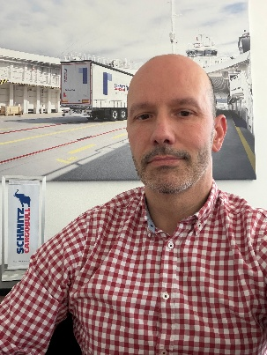
Caption: Attila Kiss, new Country Manager for Schmitz Cargobull Hungary

About Schmitz Cargobull
Schmitz Cargobull is the leading manufacturer of semi-trailers for temperature-controlled freight, general cargo and bulk goods in Europe, and a pioneer in digital solutions for trailer services and improved connectivity. The company also manufactures transport cooling units for refrigerated box body semi-trailers for temperature-controlled freight transport. With a comprehensive range of services from financing, spare parts supply, service contracts and telematics solutions to used vehicle trading, Schmitz Cargobull supports its customers in optimising their total cost of ownership (TCO) and digital transformation.
Schmitz Cargobull was founded in 1892 in Münsterland, Germany. The family-run company produces around 50,000 vehicles per year with over 6,000 employees and generated a turnover of around €2.16 billion in the financial year 2024/25. Its international production network is made up of factories in Germany, Lithuania, Spain, Turkey, Romania and the UK.

The Schmitz Cargobull press team:
Anna Stuhlmeier +49 2558 81-1340 I anna.stuhlmeier@cargobull.com
Andrea Beckonert +49 2558 81-1321 I andrea.beckonert@cargobull.com
Silke Hesener +49 2558 81-1501 I silke.hesener@cargobull.com

