Presse-Information
2019-157

New Supervisory Board of Schmitz Cargobull AG

Horstmar, September 2019 - In the context of a long planned plan of generation change, Schmitz Cargobull AG announced the reorganization of the Supervisory Board at the Annual General Meeting on September 24, 2019.

With the expiration of their mandates, Supervisory Board Chairman Professor Dr. Jürgen Kluge and Supervisory Board members Wolfgang Fritsch-Albert, Peter Schmitz and Dietrich Zaps ended their terms in office. Mrs. Astrid Hamker, Dr. Detlev Ruland, Professor Dr. Harald Ludanek and Dr. Hans Moormann were appointed as shareholder representatives on the Supervisory Board of Schmitz Cargobull AG.
Professor Dr. Jürgen Kluge, independent management consultant and for many years working for the management consultancy McKinsey & Company, among others also for Schmitz Cargobull, took over as Chairman of the Supervisory Board of Schmitz Cargobull AG in June 2013. He succeeded Peter Schmitz, who has held this position since 2003.
Peter Schmitz contributed significantly to the company's development as a technology and market leader for trailers with his technical innovations and his commitment to continuous improvement. He first steered the company as Managing Director and then as Chairman of the Management Board following its transformation into a stock corporation. From 2003 to 2013, he took responsibility for the company's development as Chairman of the Supervisory Board. With his 80th birthday he now ends his activity on the Supervisory Board.
Wolfgang Fritsch-Albert, until recently owner and CEO of the family-owned company Westfalen AG in Münsterland, accompanied Schmitz Cargobull as a member of the Advisory Board since 1996 and took up his Supervisory Board mandate at Schmitz Cargobull AG in 1999.
Dipl. Wirtsch.-Ing. Dietrich Zaps, Automotive Consultant, held leading positions in the international automotive supply industry for many years, including President & CEO of ThyssenKrupp Budd Comp. and member of the Executive Board of ThyssenKrupp Automotive AG for the North American business in the United States. He has served on the Supervisory Board of Schmitz Cargobull AG since 2013.

2019-157

The new Supervisory Board of Schmitz Cargobull AG now consists of the following shareholder representatives:
Astrid Hamker (1966) has many years of management experience as managing partner in the market-leading medium-sized Piepenbrock group. She is also a member of the advisory board and supervisory board of other companies, such as Drägerwerk AG, and has been President of the Wirtschaftsrat Deutschland since June 2019.
Dr. Hans Moormann (1956) is managing partner and chairman of the management board of the Jöst Group in Dülmen. He also works as a secondary occupation as a commercial judge at the Münster Regional Court and as a judge at the Regional Labour Court of Hamm and, among other things, is Chairman of the Wirtschaftsclub Westfalen (Westphalia Business Club) and, since 2019, Chairman of the Executive Board of the Foundation and Association Westfalen Initiative (Stiftung und Verein Westfalen Initiative).
Professor Dr. Harald Ludanek (1958) was responsible for the technical development at various brands in the Volkswagen Group from 1992 to 2017. From 2012 to early 2016, he was Board Member for Research and Technical Development at the truck manufacturer Scania in Sweden and most recently Board Member for Research and Development at Volkswagen Commercial Vehicles. He has been a member of the Schmitz Cargobull AG Innovation Circle since 2018.
Dr. Detlev Ruland (1959) has been a member of the Digital Advisory Board of KUBIKx since 2018. Before that, he was Chairman of the Board of Management of the German Research Center for Artificial Intelligence (DFKI) in Kaiserslautern and Saarbrücken. He also worked for McKinsey & Company, Inc. and RWE AG as Group Chief Information Officer before joining Deutsche Post AG in 2018 as Chief Information Officer and Chief Technology Officer.
Dirk Hoffmann (1966), a member of the Supervisory Board of Schmitz Cargobull AG since 2013, was appointed new Chairman of the Supervisory Board. After completing his vocational training at Schmitz Cargobull, he worked for many years in management functions in sales. In 1995, he founded with his wife EWT Truck & Trailer Handels GmbH, the importer for Schmitz Cargobull in Poland, the Czech Republic and Slovakia.
2019-157

Robin J Stalker (1958), Certified Public Accountant, joined Arthur Young (now EY) in New Zealand and London and held various positions in finance and controlling in the entertainment industry in Asia and the United States before becoming Chief Financial

Officer (CFO) of adidas AG. He is a member of the Supervisory Board of Schaeffler AG and has been a member of the Supervisory Board of Schmitz Cargobull AG since 2017.

At the end of August, the regular election of employee representatives to the Supervisory Board took place. Yvonne Seggewiß, Works Council Member at the Schmitz Cargobull plant in Vreden, and Hans-Joachim Hebing of IG-Metall left the Supervisory Board at their own request. Manuel Terhürne, Works Council Vreden plant and Pietro Bazzoli,
IG Metall, were elected as their successors.

The employee representatives on the Supervisory Board of Schmitz Cargobull AG are Heinz Pfeffer, Managing Director of IG Metall Rheine, Pietro Bazzoli, Managing Director of IG Metall Bocholt, Thomas Meißner, Work Council Chairman Cargobull Parts & Services, Thomas Schwier, Work Council Chairman Schmitz Cargobull Altenberge/Horstmar, Manuel Terhürne, Work Council Chairman Vreden, Volker Flatau, Head of Product Line Curtainsider at Schmitz Cargobull AG.

On behalf of the shareholders, the new Chairman of the Supervisory Board, Dirk Hoffmann, thanked the departing members of the Supervisory Board for their commitment and their contribution that kept Schmitz Cargobull on the road to success. "With the new Supervisory Board, we are tackling the challenges of the transport and logistics sector, which will certainly not diminish, in a strengthened and confident manner. We are well positioned to continue Schmitz Cargobull's success story," explained Dirk Hoffmann in his introductory speech.
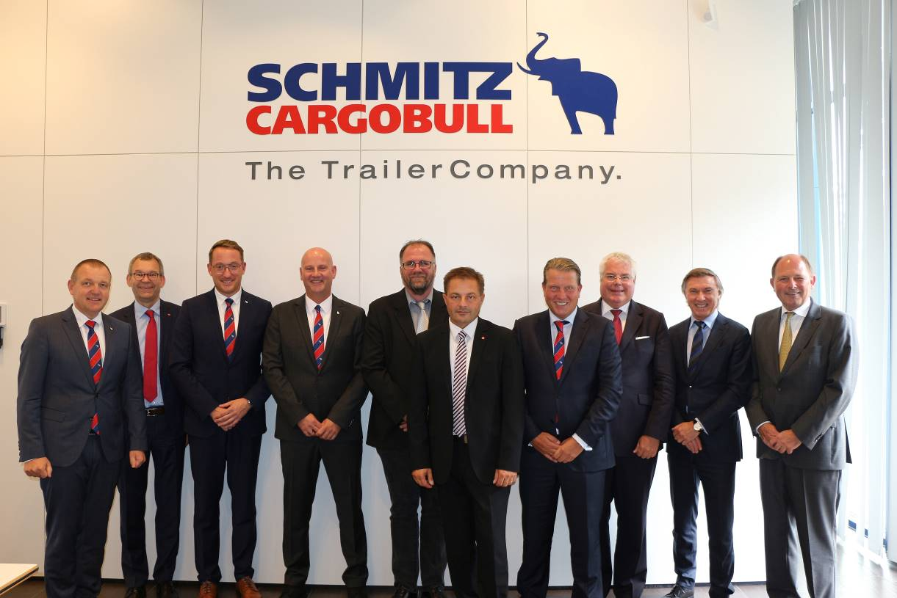

f.l.: Volker Flatau (Head of Product Line Curtainsider at Schmitz Cargobull AG), Heinz Pfeffer, Managing Director of IG Metall Rheine), Manuel Terhürne (Works Council Vreden), Thomas Schwier (Work Council Chairman Schmitz Cargobull Altenberge/Horstmar), Thomas Meißner (Work Council Chairman Cargobull Parts & Services), Pietro Bazzoli (Managing Director of IG Metall Bocholt); Dirk Hoffmann (Chairman of the Supervisory Board of Schmitz Cargobull AG), Dr. Detlev Ruland (Digital Advisory Boards KUBIKx), Robin J Stalker (Certified Public Accountant), Dr. Hans Moormann (managing partner and chairman of the management board of the Jöst Group in Dülmen)
Image: Schmitz Cargobull

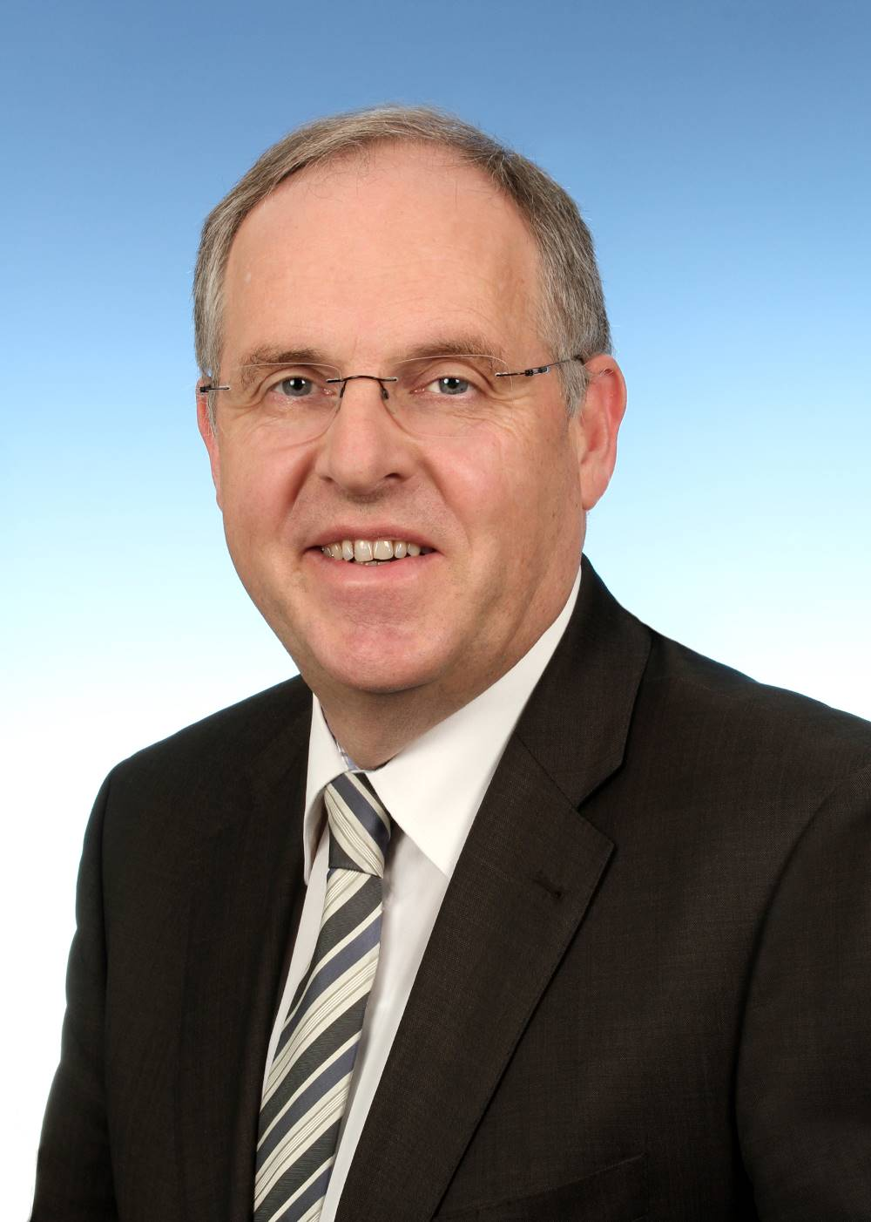
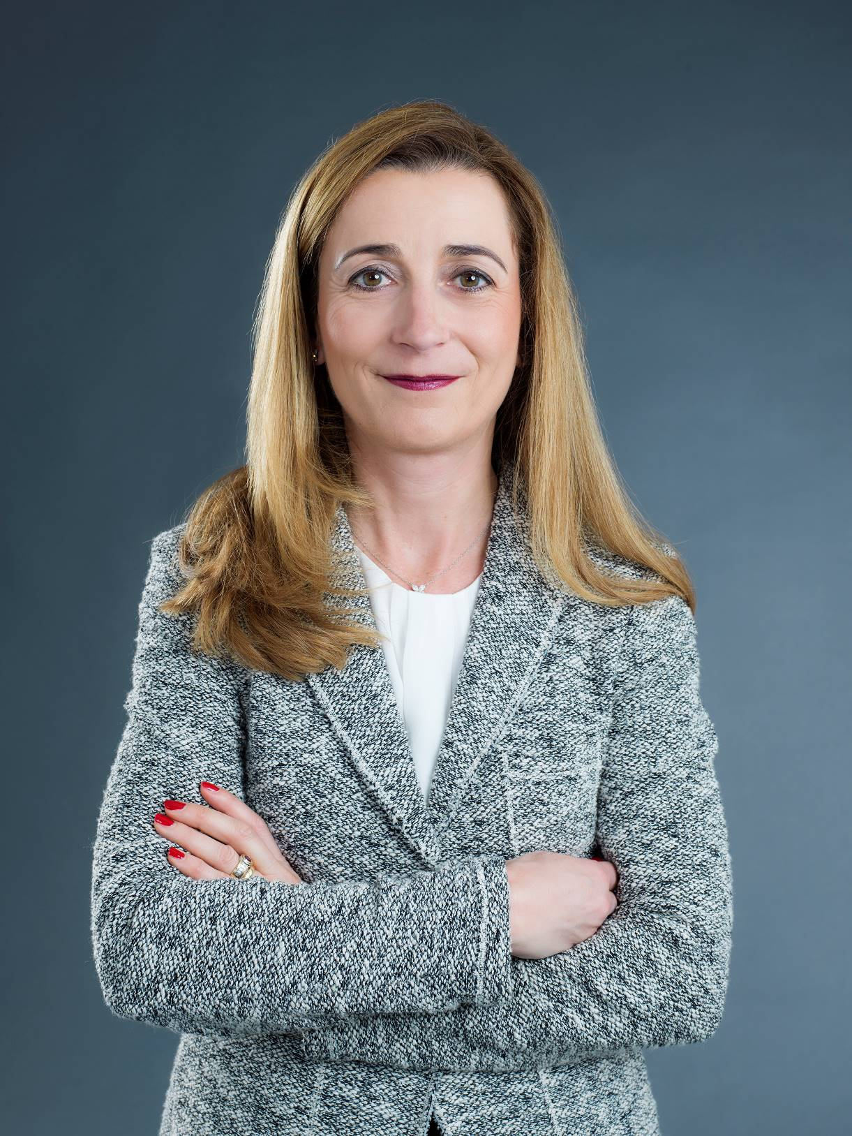

Astrid Hamker Professor Dr. Harald Ludanek (President of the Wirtschaftsrat Deutschland) (Member of the Schmitz Cargobull AG Image: Nell Killius Innovation Circle)
Image: Prof. Ludanek
About Schmitz Cargobull
With an annual production of approx. 63,500 trailers and around 6,500 employees, Schmitz Cargobull AG is Europe's leading manufacturer of semi-trailers, trailers and truck bodies for temperature-controlled freight, general cargo and bulk goods. The company achieved sales of approx. € 2.29 billion in the 2018/19 financial year. As a pioneer in the industry, the North German company developed a comprehensive brand strategy early on and consistently established quality standards spanning every level: from research and development, to production and specialist services such as consulting, trailer telematics, financing, spare parts and used vehicles.

Schmitz Cargobull Press-Team:
Anna Stuhlmeier +49 2558 81-1340 I anna.stuhlmeier@cargobull.com
Andrea Beckonert +49 2558 81-1321 I andrea.beckonert@cargobull.com
Silke Hesener +49 2558 81-1501 I silke.hesener@cargobull.com

