Press Release
2022-145

Focus on customer value and sustainability
Schmitz Cargobull and TIP Trailer Services set digital milestone for frictionless digital data provision

September 2022 - Schmitz Cargobull and TIP Trailer Services have concluded an agreement that, with immediate effect, Schmitz Cargobull trailers can automatically transfer trailer data from the standardized TrailerConnect® hardware to the TIP Insight system. This enables transport companies that use telematics systems from trailer manufacturer Schmitz Cargobull and services from equipment service provider TIP Trailer Services to decide freely in which system the data should be displayed. This uncomplicated and convenient solution is made possible by a cooperation between Cargobull Telematics and TIP Insight: the standardized interface of TrailerConnect® was integrated into the TIP Insight system.

"For transport companies, the topics of data standardization, interoperability and consolidation, and thus open interfaces, are key expectations in order to realize digitalization," Marnix Lannoije, Managing Director of Schmitz Cargobull Telematics and Theo de Vries, Commercial Vice President Maintenance and Repair and TIP Insight, explain in a joint statement.

"The use of the standardized TrailerConnect® hardware in the Schmitz Cargobull Trailer is the most sustainable and economically sensible decision to respond to the increasing demand for digitalization. The TrailerConnect® hardware enables continuous analysis of real-time trailer data and forms the basis for networked services, significantly increasing sustainability and competitiveness. Smooth data provision requires both standardization of data and interoperability of systems as elementary building blocks. Our customers speak with one voice on this issue: they want to access all vehicle data as quickly, easily and transparently as possible in order to manage their fleets and operations even more efficiently. We are now ensuring this with the compatibility of TIP Insight and Cargobull Telematics. Every customer can call up all the data they need in their preferred telematics portal. An important milestone in making digitalization a reality for many transport companies."

2022-145

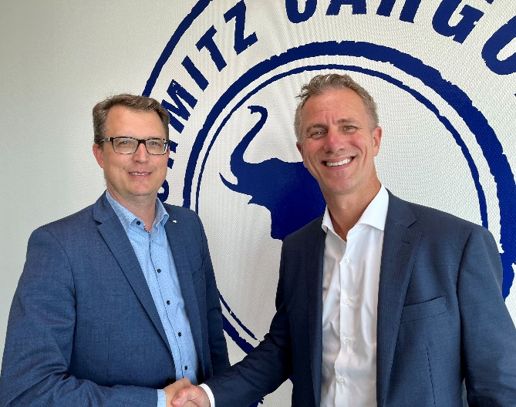
Caption: f.l.: Marnix Lannoije, Managing Director, Schmitz Cargobull Telematics and Theo de Vries, Commercial Vice President Maintenance and Repair and TIP Insight

About TIP Trailer Services
Headquartered in Amsterdam, the Netherlands, TIP is one of Europe and Canada’s leading equipment service providers, specialising in trailer leasing, rental, maintenance and repair, as well as other value-added services and provides these to transportation and logistics customers across Europe and Canada. TIP services customers from more than 120 locations spread over 18 countries in Europe and Canada. For more information, please visit our website or follow us on LinkedIn.

TIP Trailer Services
Rogier Laan
Vice President Sales and Marketing
Rogier.Laan@tipeurope.com

About Schmitz Cargobull
With an annual production of around 61,000 trailers and with approximately 6,900 employees, Schmitz Cargobull AG is Europe’s leading manufacturer of semi-trailers, trailers and truck bodies for temperature-controlled freight, general cargo and bulk goods. The company achieved sales of around €2.3 billion in the 2021/22 financial year. As a pioneer in the industry, the North German company developed a comprehensive brand strategy early on and consistently established quality standards spanning every level: from research and development, through production and service contracts, to trailer telematics, financing, spare parts, and used vehicles.

The Schmitz Cargobull press team:
Anna Stuhlmeier +49 2558 81-1340 I anna.stuhlmeier@cargobull.com
Andrea Beckonert +49 2558 81-1321 I andrea.beckonert@cargobull.com
Silke Hesener: +49 2558 81-1501 I silke.hesener@cargobull.com

