Press Release
2023-118

Schmitz Cargobull AG
Production of Schmitz Cargobull motor vehicle bodies moves to Gotha and Panevėžys
April 2023 - Schmitz Cargobull has confirmed that it will continue the production of motor vehicle bodies at its Gotha and Panevėžys plants, following the closure of GRW’s factory in Toddin, Germany on April 3. At the site, silo and tanker manufacturer GRW had produced the Schmitz Cargobull motor vehicle superstructures in contract manufacturing.
“This is sad news for GRW but due to the Schmitz Cargobull flexible production network we are able to rapidly respond to the closure of their plant without any impact on our business,” says Andreas Schmitz, CEO of Schmitz Cargobull AG. “We are moving the production of motor vehicle box bodies to our plants in Gotha, Germany and Panevėžys, Lithuania. Our customers will continue to receive their vehicles in proven Schmitz Cargobull quality."
The company’s plant in Lithuania is centrally responsible for the production of box bodies for food distribution transport in the Schmitz Cargobull Group, while bodies are also manufactured in Gotha. Significant expertise and experience in production is available at these locations and shared between them.
In the food distribution sector, Schmitz Cargobull offers a comprehensive product portfolio with customised bodies. This includes temperature-controlled motor vehicle box bodies M.KO, as well as box body trailers A.KO and central axle box body trailers Z.KO. The vehicles can be serviced and repaired by one of the 1,700 service partners authorised by Schmitz Cargobull in Europe.

2023-118

Andreas Schmitz, CEO Schmitz Cargobull AG

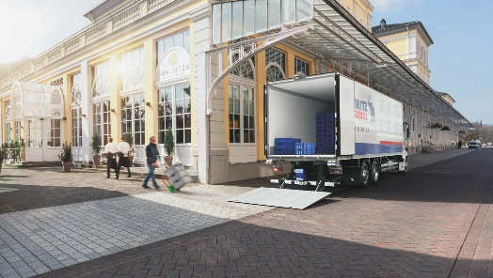

Box Body M.KO for food distribution

About Schmitz Cargobull
With an annual production of around 61,000 trailers and with approximately 6,900 employees, Schmitz Cargobull AG is Europe’s leading manufacturer of semi-trailers, trailers and truck bodies for temperature-controlled freight, general cargo and bulk goods. The company achieved sales of around €2.3 billion in the 2021/22 financial year. As a pioneer in the industry, the North German company developed a comprehensive brand strategy early on and consistently established quality standards spanning every level: from research and development, through production and service contracts, to trailer telematics, financing, spare parts, and used vehicles.

The Schmitz Cargobull press team:
Anna Stuhlmeier +49 2558 81-1340 I anna.stuhlmeier@cargobull.com
Andrea Beckonert +49 2558 81-1321 I andrea.beckonert@cargobull.com
Silke Hesener: +49 2558 81-1501 I silke.hesener@cargobull.com

