Press Release
2023-134

Schmitz Cargobull AG
Schmitz Cargobull and TIP Group focus on smooth digital data provision
2,500 trailers to have telematics retrofitted for more transparency in the fleet

November 2023 - TIP Group, one of the leading providers of trailer rental, leasing and service in Europe, and Schmitz Cargobull, Europe’s largest manufacturer of semi-trailers, have signed a contract to retrofit 2,500 trailers with telematics systems. The TrailerConnect® hardware retrofits include vehicles of all trailer types and manufacturers and are scheduled to be completed by the end of 2025.

“Retrofitting trailers with telematics is a sensible investment for all transport companies in order to increase fleet performance. Transparency and measurement is the first step towards increasing efficiency,” says Andreas Schmitz, CEO of Schmitz Cargobull AG. “New trailers should always be equipped with an open, compatible telematics system as soon as they are purchased. With TrailerConnect®, TIP has opted for a telematics system that guarantees high quality and reliability, even when retrofitting. Customers can access all the data they need. The improved transparency increases efficiency and reduces costs.”

With the telematics retrofit, TIP aims to create more transparency in its global trailer fleet of around 130,000 vehicles in order to reduce operating costs and avoid unpredictable breakdowns in vehicle rental. Installing and activating the telematics system on an S.CS curtainsider semi-trailer or an S.BO EXPRESS box body semi-trailer only takes around 30 minutes per vehicle, so there is no long downtime. Retrofitting can be carried out easily for trailers of all brands as part of the regular maintenance intervals.

“By retrofitting 2,500 trailers, we are taking a big step towards a fully networked fleet, greater transparency, efficiency and safety,” says Theo de Vries, Vice President Services and Insight at TIP Group. “Telematics provides customers with real-time data on the condition and performance of the trailers, and we use the historical trailer data to determine and plan maintenance stops in order to further optimise the availability and predictability of the vehicles.”

2023-134

Thanks to the standardised interface between Schmitz Cargobull’s TrailerConnect® system and the TIP Insight system, the telematics data of the retrofitted trailers is transmitted automatically. The TIP Insight System is a cloud-based platform that provides real-time data on the location, condition and use of trailers. This enables transport companies to manage their fleets more efficiently, increase capacity utilisation, improve safety and reduce environmental impact.

The framework agreement between Cargobull Telematics and TIP stipulates that every vehicle ex works with standardised telematics or with retrofitted telematics is automatically transferred to the TIP Insight system. This is a clear advantage for TIP, as all trailers are displayed on one platform. The TIP customer therefore receives a reliable data record for each vehicle, regardless of whether it is retrofitted or equipped ex works, and can then use the data to optimise their own processes.

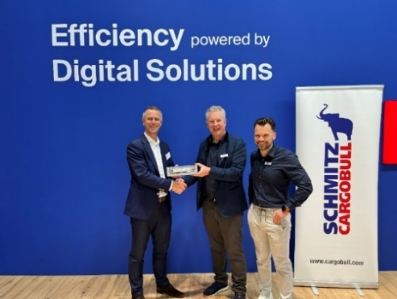
From left: Happy about the further cooperation: Theo de Vries, Vice President Services and Insight, TIP Group, Andreas Schmitz, Chairman of the Board Schmitz Cargobull AG, Simon Mols, Head of Service Sales, Product Line Digital Services, Schmitz Cargobull

About TIP Group
Headquartered in Amsterdam, the Netherlands, TIP is one of the leading equipment service providers in Europe and Canada, specialising in trailer leasing, rental, maintenance, repair and other value-added services, which it offers to transport and logistics customers throughout Europe and Canada. TIP serves its customers from more than 120 locations in 18 countries in Europe and Canada. For more information, please visit our website or follow us on LinkedIn.

About Schmitz Cargobull
Schmitz Cargobull is the leading manufacturer of semi-trailers for temperature-controlled freight, general cargo and bulk goods in Europe and a pioneer in digital solutions for trailer services and improved connectivity. The company also manufactures transport refrigeration machines for refrigerated semi-trailers for temperature-controlled freight transport. With a comprehensive range of services from financing, spare parts supply, service contracts and telematics solutions to used vehicle trading, Schmitz Cargobull supports its customers in optimising their total cost of ownership (TCO) and digital transformation.
Schmitz Cargobull was founded in 1892 in Münsterland, Germany. The family-run company produces around 60,000 vehicles per year with over 6,000 employees and generated a turnover of around 2.6 billion euros in the 2022/23 financial year. The international production network currently comprises ten plants in Germany, Lithuania, Spain, England, Turkey, Slovakia and Australia.

The Schmitz Cargobull press team:
Anna Stuhlmeier +49 2558 81-1340 I anna.stuhlmeier@cargobull.com
Andrea Beckonert +49 2558 81-1321 I andrea.beckonert@cargobull.com
Silke Hesener +49 2558 81-1501 I silke.hesener@cargobull.com

