Press Release
2025-168

Schmitz Cargobull AG
Schmitz Cargobull Ibérica receives CAAR Award for Industrial Process Innovation

October 2025 - At the VII Aragon Automotive and Mobility Night, organised by the Aragon Automotive and Mobility Cluster (CAAR), Schmitz Cargobull Ibérica was presented with the prestigious CAAR Award for Industrial Process Innovation.

The award was given for the development of an innovative automated guided vehicle (AGV) specially designed for the internal transport of semi-trailers more than 13 metres long and weighing up to 11 tonnes. This technological solution marks a significant advance in industrial automation. It increases production capacity, improves ergonomics and safety in the workplace, and enables comprehensive digitalisation of the process through real-time statistics and incident analyses.

"We are delighted to receive this recognition. It underlines our commitment to innovation, efficiency and safety in the industry. Our thanks go not only to the CAAR, but above all to our highly motivated production team, who made this achievement possible," says Jordi Romero, Managing Director of Schmitz Cargobull Ibérica.

Schmitz Cargobull is consistently pursuing its path of digital transformation and operational excellence. The international production network with production sites in Germany, Lithuania, Spain, the UK and Turkey, enables responsive, efficient production with short delivery times, close to the customer. Schmitz Cargobull has already been honoured with the German elogistics award 2025 for its flexible and sustainable management of operational logistics processes in the production network.

2025-168

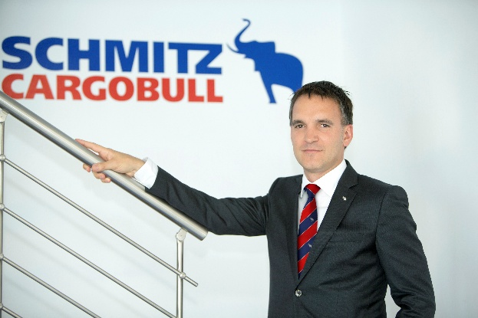
Caption: Jordi Romero, Managing Director, Schmitz Cargobull Ibérica.

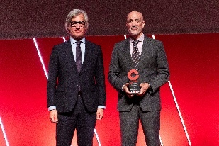
Caption: (from left) Ricardo Duarte, WEU/CEE Regional Sales Manager TÜV Rheinland and Andrés Rodríguez, Head of Industrial Engineering and Maintenance, Schmitz Cargobull Ibérica.

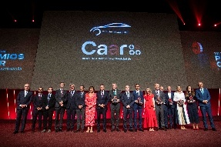
Caption: Group photo of the CAAR award winners.

About Schmitz Cargobull
Schmitz Cargobull is the leading manufacturer of semi-trailers for temperature-controlled freight, general cargo and bulk goods in Europe, and a pioneer in digital solutions for trailer services and improved connectivity. The company also manufactures transport cooling units for refrigerated box body semi-trailers for temperature-controlled freight transport. With a comprehensive range of services from financing, spare parts supply, service contracts and telematics solutions to used vehicle trading, Schmitz Cargobull supports its customers in optimising their total cost of ownership (TCO) and digital transformation.
Schmitz Cargobull was founded in 1892 in Münsterland, Germany. The family-run company produces around 50,000 vehicles per year with over 6,000 employees and generated a turnover of around €2.16 billion in the financial year 2024/25. Its international production network is made up of factories in Germany, Lithuania, Spain, the UK and the Republic of Türkiye.

The Schmitz Cargobull press team:
Anna Stuhlmeier +49 2558 81-1340 I anna.stuhlmeier@cargobull.com
Andrea Beckonert +49 2558 81-1321 I andrea.beckonert@cargobull.com
Silke Hesener +49 2558 81-1501 I silke.hesener@cargobull.com

