Press Release
2023-124

Schmitz Cargobull AG
Schmitz Cargobull electric reefer semi-trailer with
e-axle secures type approval
Schmitz Cargobull is the first OEM with type approval for the fully-electric reefer semi-trailer S.KOe COOL with generator axle
July 2023 - Schmitz Cargobull has become the first trailer manufacturer to officially include the electric generator axle of the S.KOe COOL semi-trailer in its overall vehicle type approval, further enhancing its reputation as an industry pioneer. The approval has been officially granted by the German Federal Motor Transport Authority (Kraftfahrtbundesamt).
The S.KOe COOL fully-electric reefer semi-trailer meets all the relevant statutory safety, environmental and production requirements of the European Union. Proof was provided by means of prescribed type tests on a vehicle or the vehicle components. The systems were approved with the support of TÜV Rheinland. The required type test for the complete vehicle approval of the S.KOe COOL three-axle, fully-electric semi-trailer was successfully carried out by the technical service of SGS TÜV.
Schmitz Cargobull has already been working with TÜV Rheinland in a trusting relationship on all electrification projects since 2014 and was also able to bring this project to a successful conclusion.
"We are delighted to be the first OEM to receive this type approval for our fully-electric S.KOe COOL semi-trailer," said Boris Billich, Chief Sales Officer at Schmitz Cargobull. "This confirms to our customers that they are being provided with a tested overall system ex works that complies with all applicable European regulations. The safe and environmentally compatible operation of the vehicle therefore takes place without any subsequent and additional administrative testing effort."

2023-124

The all-electric S.KOe COOL refrigerated box was recently presented with the German Award for Sustainability Projects 2023 in the "Technology - Energy" category.

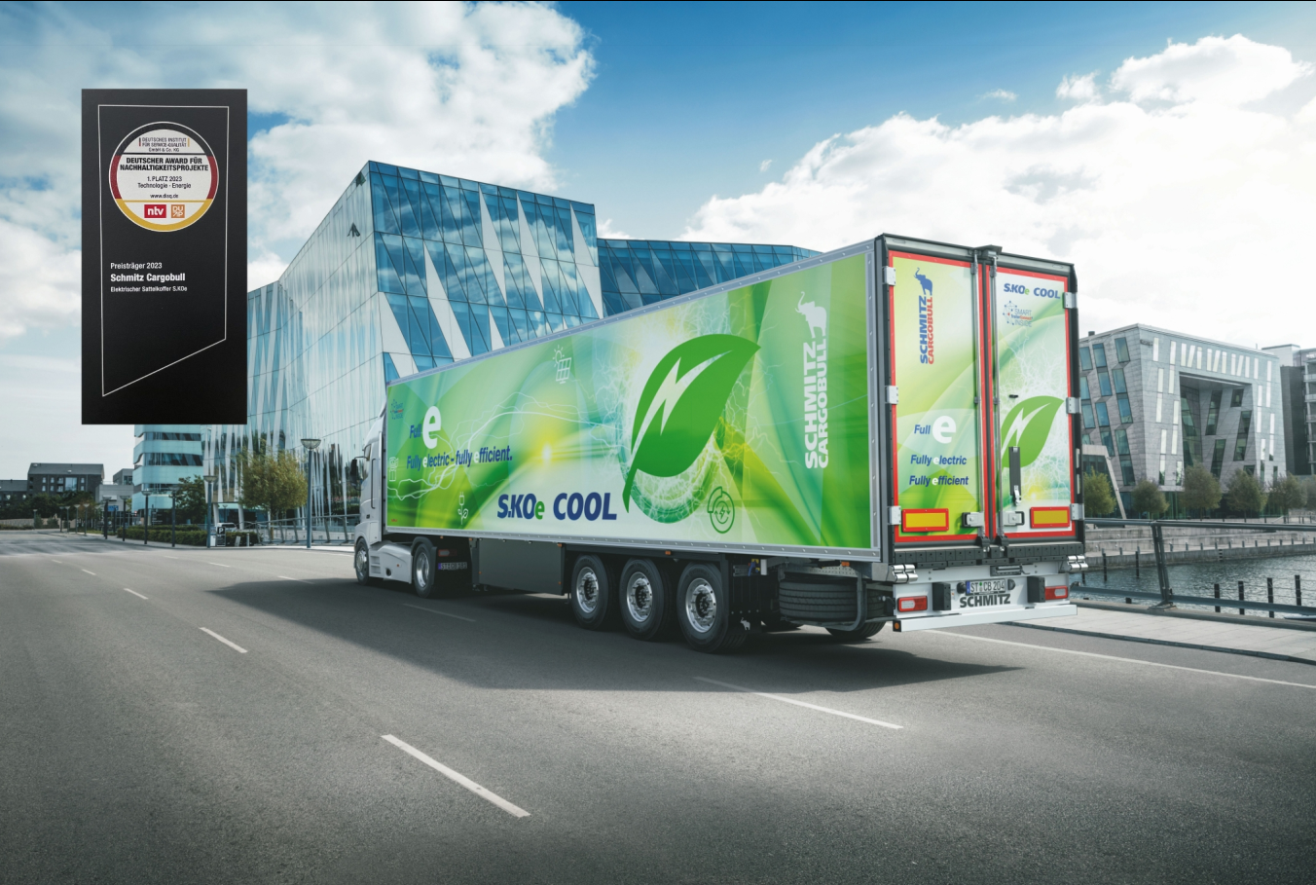
Caption: Schmitz Cargobull is the first OEM with type approval for the fully-electric S.KOe COOL reefer semi-trailer with generator axle.

About Schmitz Cargobull
With an annual production of around 61,000 trailers and with approximately 6,900 employees, Schmitz Cargobull AG is Europe’s leading manufacturer of semi-trailers, trailers and truck bodies for temperature-controlled freight, general cargo and bulk goods. The company achieved sales of around €2.3 billion in the 2021/22 financial year. As a pioneer in the industry, the North German company developed a comprehensive brand strategy early on and consistently established quality standards spanning every level: from research and development, through production and service contracts, to trailer telematics, financing, spare parts, and used vehicles.

The Schmitz Cargobull press team:
Anna Stuhlmeier +49 2558 81-1340 I anna.stuhlmeier@cargobull.com
Andrea Beckonert +49 2558 81-1321 I andrea.beckonert@cargobull.com
Silke Hesener +49 2558 81-1501 I silke.hesener@cargobull.com

