Press Release
2021-152

Schmitz Cargobull AG
STI (Deutschland) GmbH is committed to electromobility
First fully electric S.KOe reefer semi-trailer handed over

September 2021 - STI (Deutschland) GmbH, a subsidiary of STI Freight Management GmbH, has committed itself to electromobility in its fleet. For this reason, the company has now taken delivery of the first fully electric Schmitz Cargobull S.KOe reefer semi-trailer with an electric transport cooling unit and generator axle for everyday operations in the multi-temp sector. This makes STI the first company in Germany to operate the S.KOe on coordinated routes in a field test. If the fully electric reefer semi-trailer stands the test, the company intends to invest in further e-trailers in the future.

As a logistics company operating throughout Europe, STI is aware of its responsibility in shaping a more sustainable future. “We don't just want to raise awareness that something needs to change, we want to be proactive and use technological solutions to significantly reduce our CO2 emissions. That’s why we decided early on to use an fully electric S.KOe reefer semi-trailer from Schmitz Cargobull,” explains Drazan Malesevic, Managing Director of STI (Deutschland) GmbH.

“We want to understand how the trailer works in everyday operations and, through consistent data collection over the next two years, determine how sustainable the
e-trailer is in our business segment, taking into account the highest qualitative requirements. In this we work together closely with Schmitz Cargobull. If the testing is successful, we will equip most of our fleet with e-trailers in the future. This potentially means that more than 200 trailers would legitimately carry the Zero Emission logo,” adds Oliver Exner (Senior Operations Manager STI).

Schmitz Cargobull is currently delivering the first fully electric semi-trailers for everyday operations. The reefer semi-trailer handed over to STI is an S.KOe COOL SMART with an electric axle as well as an electric cooling unit with integrated power electronics and a battery system.

2021-152

The all-electric S.CUe cooling unit is designed for emission-free cooling and heating of the freight in the multi-temp range. The S.CUe has a cooling capacity of up to 15,900 W and a heating capacity of 9,100 W. Batteries are installed in the place of the diesel tank between the landing gear.

In addition, the trailer is equipped with an electrified Schmitz Cargobull trailer axle which, among other things, recuperates energy during braking processes and thus reduces the charging times of the battery via the power supply network. On a trailer without an electrified axle the battery is not recharged when the vehicle is in motion. In contrast, a trailer with a generator axle recharges the battery during the journey, minimising the need for recharging via the power supply network at the distribution centre. This also reduces waiting times at the distribution centres.

The Schmitz Cargobull TrailerConnect telematics system, which is integrated in the vehicle as standard, can be used to monitor the battery charge status, the remaining range and the remaining charging time via the telematics portal.

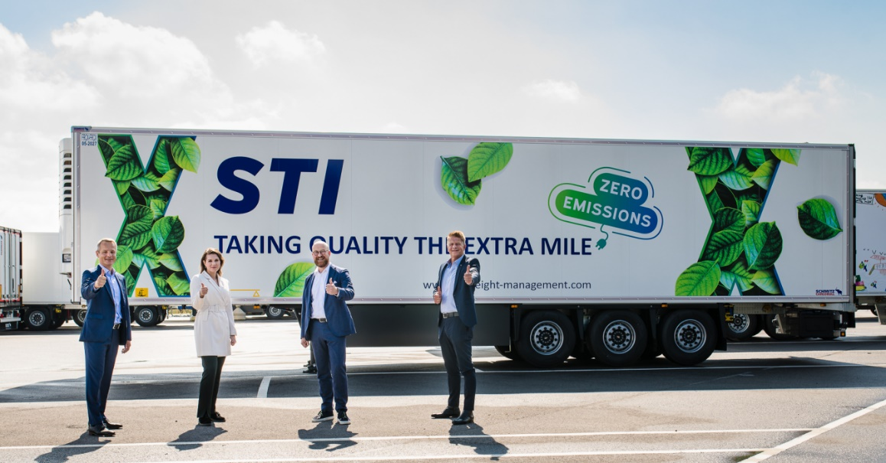
Caption: Vehicle handover in the vehicle delivery yard in Vreden
From left: Frank Reppenhagen (Head of Sales Germany and Western Europe Region, Schmitz Cargobull), Liene Elste (Trailer Coordinator STI), Oliver Exner (Senior Operations Manager STI), Matthias Robert (Head of Sales Area Borken, Schmitz Cargobull)
(All persons in the photo provided proof of a negative coronavirus test result beforehand)

2021-152

About STI:
STI Freight Management has been one of the leading providers of temperature-controlled transport throughout Europe for over 37 years and specialises in the planning and execution of complex transport and logistics projects. The European STI network is strategically located with 14 sites in nine countries. The subsidiary of HAVI Global Logistics and Martin-Brower UK Holdings (Ltd.) currently employs over 260 people and, as a company, organises international transports for the food sector as well as temperature-controlled transports for the pharmaceutical industry. STI sees itself not only as a quality leader, but also as a sustainable company that, by combining traditional and digital freight management services, offers tailored and efficient logistics solutions that help to minimise the ecological footprint and thus protect the environment.
Media contact STI Freight Management
Andrea Küster +49 2065 708 4487 andrea.kuester@sti-fm.com

About Schmitz Cargobull
With an annual production of more than 46,000 trailers and with around 5,700 employees, Schmitz Cargobull AG is Europe’s leading manufacturer of semi-trailers, trailers and truck bodies for temperature-controlled freight, general cargo and bulk goods. The company achieved sales of approximately €1.87 billion in the 2019/2020 financial year. As a pioneer in the industry, the North German company developed a comprehensive brand strategy early on and consistently established quality standards spanning every level: from research and development, through production and service contracts, to trailer telematics, financing, spare parts, and used vehicles.

The Schmitz Cargobull press team:
Anna Stuhlmeier +49 2558 81-1340 I anna.stuhlmeier@cargobull.com
Andrea Beckonert +49 2558 81-1321 I andrea.beckonert@cargobull.com
Silke Hesener: +49 2558 81-1501 I silke.hesener@cargobull.com

