Presse-Information
2020-140

Schmitz Cargobull AG
Smart Trailer Days: Sustainably efficient and digitally networked

The latest product and service innovations from Schmitz Cargobull

September 2020 – In keeping with the motto "Smart Trailer Days", Schmitz Cargobull will be presenting the latest product and service innovations which help to reduce the Total Costs of Ownership (TCO) in the fleet. One highlight is the introduction of telematics as standard equipment for curtainsiders. The main focus of product developments was on reducing weight while maintaining the same robustness, cooling efficiency for temperature-controlled freight and digital networking.

Here is a preview of the innovations:
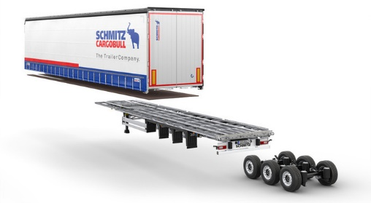

S.CS Curtainsider - New: THE SMART GENERATION
- The rolled chassis, bolted and galvanised, is now a consistent principle for all vehicle chassis, from the weight-optimised new X-LIGHT trailer to the heavy-duty version with high load capacity. Featuring a 10-year warranty against rust-through on all galvanised chassis parts.
- Strong and lightweight: The new X-LIGHT curtainsider semitrailer, with a tare weight starting at 4,975 kilograms, combines maximum payload with Schmitz Cargobull’s proven robustness. The chassis can be combined with various body variants, such as MEGA, COIL or PAPER.
- 100% SMART: all S.CS curtainsiders are now equipped with our TrailerConnect® CTU telematics system as standard. Giving you full transparency of your trailer fleet.
- New POWER CURTAIN tarpaulin, fully certified for the transport of tyres and non-stable goods.

For more Information see Press-Releases 2020-300 und 2020-301

2020-140
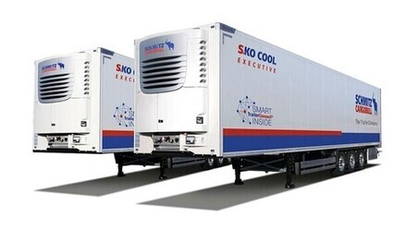
S.KO COOL SMART box semitrailer
- Cool with safety: The new robust air distribution system optimises air flow in the trailer, for efficient and uniform cooling of the load.
- Our latest generation temperature printer can print current and historical temperature data from the last 12 months in 21 languages.
- Automated door lock control using geofencing: Locking and unlocking of the TL3 door lock system without manual effort for dispatch or driver. This saves time and increases safety.
- The S.KOe E-Trailer is perfect for "zero emission" zones in cities: The S.CUe electric cooling unit uses energy from our new electric trailer axle, meaning NOx and CO₂ emissions are reduced to zero.
For more Information see Press-Releases 2020-503 und 2020-505
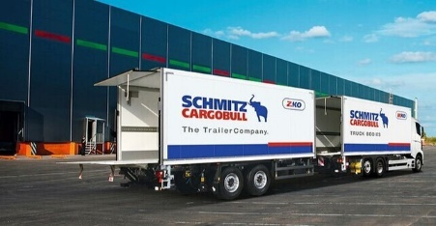
​

Truck bodies

- New generation of M.KO/Z.KO truck bodies and drawbar trailers: ATP / FRC certification for M.KO COOL models – featuring an optimised body design for even better insulation.
- Weight reduction for more payload and improved loading possibilities in drawbar configurations.
- Maximum flexibility and cooling performance for MultiTemp operations, with partition walls allowing for 1/3 and 2/3 division of the body.
- New side collision protection, optional front corner protection
For more Information see Press-Release 2020-708

2020-140

Tipper vehicles: weight down - flexibility up
- The new generation of frame within the S.KI tipper trailer offers up to 180 kg more payload with consistently high quality and improved corrosion protection.

- Back in the range: The Z.KI central axle tipper, with newly developed tipper body, offers pallet width as standard and approx. 60 kg more payload.

- Our M.KI rigid truck tipper body now offers payload optimised thermal insulation for the highways construction sector. Universally applicable: with 18 m³ capacity, the M.KI is ideal for transporting small quantities of asphalt and bulk materials.
For more Information see Press-Releases 2020-708, 2020-709 und 2020-710

For efficient, digital transport management - TrailerConnect® telematics makes our trailers SMART
- New: Telematics now standard in the S.CS SMART curtainsider semitrailer
- TrailerConnect® CTU - the new telematics solution especially for curtainsiders and dry freight trailers
- TrailerConnect® Portal – to monitor your fleet live
- TrailerConnect® TyreManager
- TrailerConnect® Automated door lock control

For more Information see Press-Release 2020-141

2020-140

Services for everyday transport - always safely on the road
- New among the full-service contracts is the entry-level contract ServiceTrailer, which covers material and labour costs for maintenance and wear of axle and brake components.

For more Information see Press-Release 2020-142

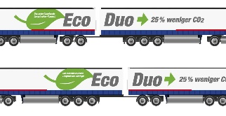
Transport concept EcoDuo
- In the EcoDuo combination, two standard semi-trailers - connected to each other via a dolly - are coupled to a tractor unit.

- Schmitz Cargobull advocates the Europe-wide introduction of a transport concept that relieves the existing infrastructure, reduces CO2 emissions, takes into account current standards in the transport industry - especially in combined transport - and is ideal for use in long-distance transport.

For more Information see Press-Release 2020-143
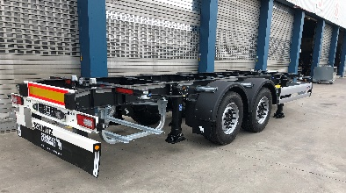

A.WF trailer swap chassis, Z.WF central axle swap chassis and W.BO swap boxes from Schmitz Cargobull
- The company is introducing the relaunch of the trailer swap chassis A.WF and central axle swap chassis Z.WF for the transport of short swap bodies and a new swap box W.BO.
- Vehicles for swap body operation are adaptable and optimally equipped. They are characterized by a simple and robust construction. Optionally they are also available in galvanized design.

For more Information see Press-Release 2020-800

2020-140

About Schmitz Cargobull
With an annual production of around 46,100* trailers and with around 5,700* employees, Schmitz Cargobull AG is Europe’s leading manufacturer of semi-trailers, trailers, and truck bodies for temperature-controlled freight, general cargo and bulk goods. The company achieved sales of approximately €1.87* billion in the 2019/2020 financial year. As a pioneer in the industry, the North German company developed a comprehensive brand strategy early on and consistently established quality standards spanning every level: from research and development, through production and service contracts, to trailer telematics, financing, spare parts, and used semi-trailers.

*preliminary figures for the 2019/20 financial year (01.04. to 31.03.)

The Schmitz Cargobull press team:
Anna Stuhlmeier +49 2558 81-1340 I anna.stuhlmeier@cargobull.com
Andrea Beckonert +49 2558 81-1321 I andrea.beckonert@cargobull.com
Silke Hesener: +49 2558 81-1501 I silke.hesener@cargobull.com

