PRESS RELEASE
2021-507

Schmitz Cargobull (UK) Ltd
SCHMITZ CARGOBULL LAUNCHES NEW DRY-FREIGHT SEMI-TRAILER MADE IN THE UK: THE S.KO PACE SMART

November 2021 - Schmitz Cargobull, Europe's leading manufacturer of semi-trailers, has revealed its first new product from its UK plant as the S.KO PACE SMART – a fully modular dry-freight semi-trailer designed for UK and Irish operators with market-specific features.

Boris Billich, Chief Sales Officer and Member of the Executive Board, says: “The launch of the S.KO PACE SMART is a significant development for the dry freight market in the UK and Ireland because of the benefits it brings to operators and because it is built in Manchester. Landed costs, carbon emissions and lead times will be significantly reduced. I am really excited to extend our product range with the S.KO PACE, a product that will provide outstanding value for UK and Irish operators.”

The S.KO PACE SMART is targeted primarily at the parcel delivery and dry freight market, combining Schmitz Cargobull’s renowned quality build with innovative honeycomb STRUKTOPLAST panels. The lightweight panels mean each trailer weighs around 600 kg less than competitor models. As a result, the tare weight of the trailer remains consistent over time, ensuring the payload potential on day one is maintained for the life of the asset. It will also significantly reduce carbon emissions over the lifetime of the trailer which operators can expect to translate into lower fuel bills.
Paul Avery, UK Managing Director Operations, explains: “The S.KO PACE SMART offers the high standards of quality and durability customers expect from Schmitz Cargobull. It is built on Schmitz Cargobull’s fully galvanised MODULOS

2021-507

chassis that has proven itself millions of times over and comes with a 10-year warranty against rust-through.”

The S.KO PACE SMART is fully EN 12642 code XL certified and offers a variety of options including load securing rails, translucent roof, tail lift and two choices of doors – rear shutter, or aluminium barn doors. Furthermore, its ROTOS axles are covered by a 1,000,000 km or six-year warranty.

It can be fitted with any load restraint to protect parcels including rear parcel safety nets or gates, and has a standard floor strength of 5.5 tonnes, with options to increase to 7.1 tonnes or 8.0 tonnes for those carrying heavier loads or needing to move materials handling equipment. The Schmitz Cargobull telematics system TrailerConnect® is fitted as a standard to provide intelligent connectivity and support fast diagnostics of all components with the telematics control unit.

Avery adds: “Opening the UK factory this year has been a fantastic opportunity and as a team we are extremely proud of the quality of the manufacturing process we have created. It is incredibly rewarding that we have had so many orders placed already.”

The Schmitz Cargobull plant in Manchester has so far created 40 jobs in production and administration and is now home of the entire UK team of currently 62 employees.

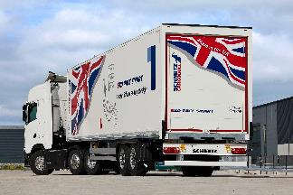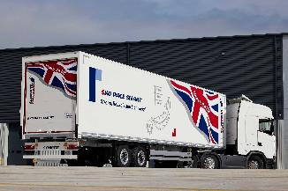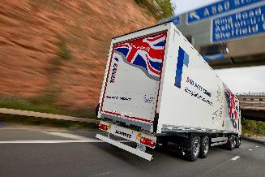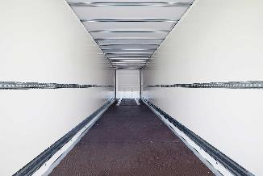

2021-507
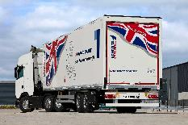
Technical Data
S.KO PACE SMART:
- Innovative, stable lightweight body made of STRUKTOPLAST
- Three body heights from 2.600 mm and 2.800 up to 3.200 mm usable interior height
- Standard floor strength of 5.5 to, with options to increase to 7.1 to or 8.0 to
- Maximum loading volume of over 108 m3
- 100 % SMART - TrailerConnect® telematics as standard ex works. Hardware and basic service are included and can be used immediately​
- More payload and less CO2 emissions due to lower total weight (6.450/5.800 kg*)
- Pallet spaces: 33 EURO pallets or 26 ISO pallets
- Bolted galvanised, MODULOS chassis - with 10-year warranty against rust-through
- ROTOS axle unit - with 1,000,000 km or 6-year warranty (excluding wear parts)​
- Simplified load securing with two load securing rails ​
- Optimal equipment for CEP services with roller shutter*, light roof* and tail lift*.​
*Value depending on design and equipment

Editor’s notes:
Schmitz Cargobull UK and Ireland is a subsidiary company of the German-owned Schmitz Cargobull Group.
With an annual production of around 42,500 trailers and with around 5,700 employees, Schmitz Cargobull AG is Europe’s leading manufacturer of semi-trailers, trailers and truck bodies for temperature-controlled freight, general cargo and bulk goods. The company achieved sales of approximately €1.74 billion in the 2020/21 financial year. As a pioneer in the industry, the North German company developed a comprehensive brand strategy early on and consistently established quality standards spanning every level: from research and development, through production and service contracts, to trailer telematics, financing, spare parts, and used vehicles.

Visit Schmitz Cargobull UK’s dedicated online press room at http://gk.news/schmitzcargobull

https://twitter.com/cargobulluk
https://www.linkedin.com/company/5183400
http://www.youtube.com/user/SchmitzCargobullUK

Press Contact UK:
Lucy Pitcher or Gemma Turner
Garnett Keeler PR
Tel: 020 8647 4467
Email: lucy.pitcher@garnettkeeeler.com or lois.spall@garnettkeeler.com
Company Contact Europe:
Anna Stuhlmeier, Head of Corporate Public Relations
Silke Hesener, Manager Public Relations
Tel: +49 02558 811501
Email: silke.hesener@cargobull.com
Andrea Beckonert, Manager Public Relations
Tel : +49 02558 811321
Email : andrea.beckonert@cargobull.com SCB/346/21

