Press Release
2026-119

Schmitz Cargobull (UK) Ltd
Invo Fulfilment expands its fleet with high-quality Schmitz
Cargobull semi-trailers

July 2026 - Manchester-based Invo Fulfilment, part of the colleague-owned Involvement Group, is focusing on strategic growth within the external transport
sector by expanding its fleet with four new S.CS FREEPOST semi-trailers from
Schmitz Cargobull. The order marks the start of a new partnership between two
companies that share a strong local presence in Manchester.

Initial contact at RTX 2025
The foundations for the collaboration were laid at RTX 2025, where the Invo Fulfilment team first came into contact with Schmitz Cargobull. As a new customer, the company set out a clear requirement: to procure high-quality, optimally equipped semi-trailers that meet the high standards of its existing fleet – without the cost-intensive additional options that are often standard on the market.

High standards for equipment and efficiency
To ensure seamless integration into its existing transport processes, Invo Fulfilment defined a detailed specification. This included, amongst other things:
• Flush doors – commonly an expensive optional extra from other manufacturers
• Galvanised chassis for durability and corrosion resistance
• Local supplier presence in Manchester for convenient factory visits and ongoing support
• Front and rear lift axles to reduce tyre wear and operational costs
• Tree guards for added protection
• Uprated glued floor to remove excess screws and reduce long-term wear
• Colour-matched air deflector to maintain brand consistency

2026-119

The solution: Four custom-built S.CS FREEPOST semi-trailers
Schmitz Cargobull presented the ideal solution with the S.CS FREEPOST. All required specifications could be implemented ex-works – without compromises or hidden additional costs.
A decisive step in the decision-making process was the testing of a demonstration vehicle. Invo Fulfilment put the semi-trailer through its paces in real-world conditions and was thoroughly impressed: from the build quality and handling to its practical suitability for daily use.

A choice for quality, proximity and reliability
Following the successful test phase, Invo Fulfilment decided to order four S.CS
FREEPOST semi-trailers – the first order placed with Schmitz Cargobull and the start of a regionally established partnership.

This investment gives the company:
• Fleet consistency
• Reduced long-term maintenance and tyre costs
• Improved durability and asset longevity
• Supplier proximity and stronger support access
• Enhanced brand presentation with matched livery

Setting the course for future growth
With the new semi-trailers, Invo Fulfilment is taking an important step in its
development strategy. The decision to choose Schmitz Cargobull supports the
company in further expanding its external transport services whilst relying on reliable, high-quality and practical technology

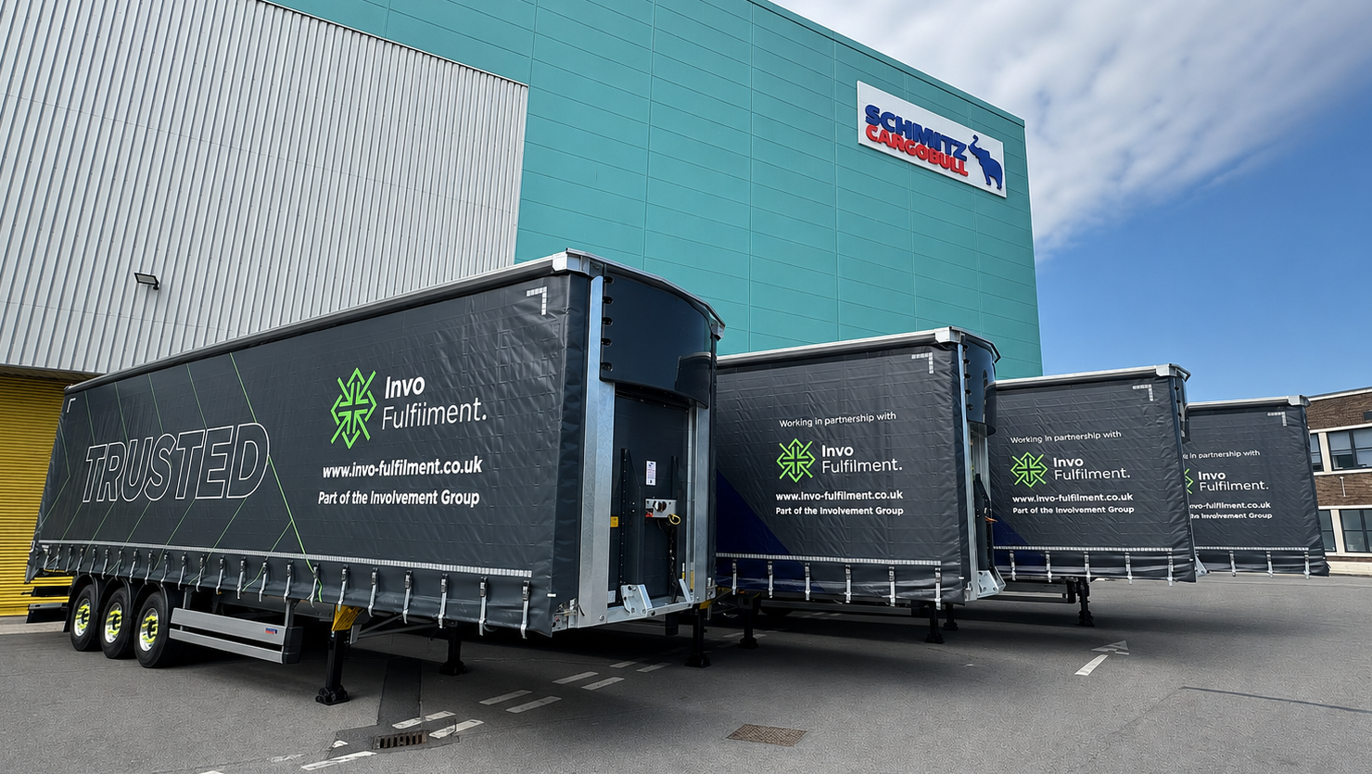

2026-119

About Schmitz Cargobull
Schmitz Cargobull is the leading manufacturer of semi-trailers for temperature-controlled freight, general cargo and bulk goods in Europe, and a pioneer in digital solutions for trailer services and improved connectivity. The company also manufactures transport cooling units for refrigerated box body semi-trailers for temperature-controlled freight transport. With a comprehensive range of services from financing, spare parts supply, service contracts and telematics solutions to used vehicle trading, Schmitz Cargobull supports its customers in optimising their total cost of ownership (TCO) and digital transformation.
Schmitz Cargobull was founded in 1892 in Münsterland, Germany. The family-run company produces around 50,000 vehicles per year with over 6,000 employees and generated a turnover of around €2.16 billion in the financial year 2024/25. Its international production network is made up of factories in Germany, Lithuania, Spain, Turkey, Romania and the UK.

About Invo Fulfilment
Invo Fulfilment’s trusted and straightforward approach to business is backed by decades of experience in the storage and distribution sector. Invo Fulfilment is part of the Involvement Group, a colleague-owned set of businesses recognised for their people-first ethos and world-class customer experience.

Press Contact Schmitz Cargobull UK:
Ruth Warwick +44 (0) 7525 068 843 I ruth.warwick-external@cargobull.com

The Schmitz Cargobull press team:

Anna Stuhlmeier +49 2558 81-1340 I anna.stuhlmeier@cargobull.com
Andrea Beckonert +49 2558 81-1321 I andrea.beckonert@cargobull.com
Silke Hesener +49 2558 81-1501 I silke.hesener@cargobull.com

