Press Release
2025-148

Schmitz Cargobull AG
Schmitz Cargobull generates 2.25 billion euros in turnover and continues to hold its position as market leader in a challenging market environment

- Sales increased to more than 47,000 vehicles
- Investments of over 55.5 million euros in production, digitalisation, and innovation
- 25 percent market share: one in four newly registered trailers in Europe comes from Schmitz Cargobull

September 2026 – Schmitz Cargobull AG has concluded the 2025/26 financial year (1 April 2025 to 31 March 2026) in a challenging economic environment, while confirming its position as Europe’s leading manufacturer of semi-trailers.
Geopolitical uncertainties, a weak economy in key European markets, and continued reluctance to invest in the transportation industry characterised the financial year.
Nevertheless, the company increased sales to more than 47,000 vehicles (previous year: 42,620) and generated turnover of approximately 2.25 billion euros (previous year: 2.16 billion euros).

EBITDA was 45.6 million euros, down from 57.1 million euros the previous year, and operating profit (EBIT) amounted to -13.3 million euros (previous year: -8.2 million euros). The earnings performance reflects ongoing market volatility, significant price pressure, and increased energy, labour, and raw material costs.

“More than 47,000 vehicles delivered is a clear sign of our customers’ confidence in the reliability and economic value of our products and services,” says Andreas Schmitz, CEO of Schmitz Cargobull AG.
“Even though we stand on a solid foundation with positive EBITDA of 45.6 million euros, the negative EBIT of -13.3 million euros makes it clear that there is still a need for action. Our clear goal is to improve our profitability in a sustainable manner. In doing so, we are consistently focusing on customer proximity and innovative strength to continue reliably supporting our customers and strengthening our competitiveness in the long term.”

2026-148

Consistent Investments in Digitalisation and Production
In financial year 2025/26, Schmitz Cargobull invested a total of 55.5 million euros in the company’s future. A key focus was on further automating production facilities and expanding the production network. In early 2026, the new production plant in Oradea, Romania, began operations to manufacture semi-trailer curtain-sided trucks and semi-trailer dump trucks for the Central European market. The plant is expected to reach an annual capacity of up to 4,000 vehicles in the future and strengthen the company’s international production network.

Approximately 5.3 million euros were invested in research and development projects to implement the digitalisation strategy and further develop digital solutions. With the Cargobull Operating System (COS) as well as new diagnostic and telematics solutions, Schmitz Cargobull is continuously expanding its digital offerings. The goal is to increase vehicle availability, optimise maintenance processes, and reduce total cost of ownership for fleet operators.

International Growth Strategy Continues to Gain Momentum
During the reporting year, Schmitz Cargobull strategically expanded its international presence and product portfolio. This includes investments in Sub Zero Insulation Technologies in India and in GT Trailers, the Polish specialist for high-volume vehicles.
The planned full acquisition of lightweight construction specialist Berger Fahrzeugtechnik is still subject to regulatory approvals. The most recent transaction took place in July 2026 with the acquisition of a majority stake in the Australian trailer manufacturer Freighter Group.

Artificial Intelligence as a Strategic Success Factor
With its group-wide AI initiative, Schmitz Cargobull aims to systematically tap into the potential of artificial intelligence. The goal is to streamline internal processes and develop new digital business models. A notable example is DR. COOL, the AI-based service assistant for transport refrigeration units. The solution supports service partners in the diagnostic and service processes for Schmitz Cargobull refrigeration units and helps reduce repair times.

Outlook for Financial Year 2026/27
For the current financial year, Schmitz Cargobull plans to increase sales to approximately 49,000 vehicles. To achieve this, the company is relying on its customer-focused

2026-148

international network and the further development of its product and service portfolio to deliver long-term value to customers.

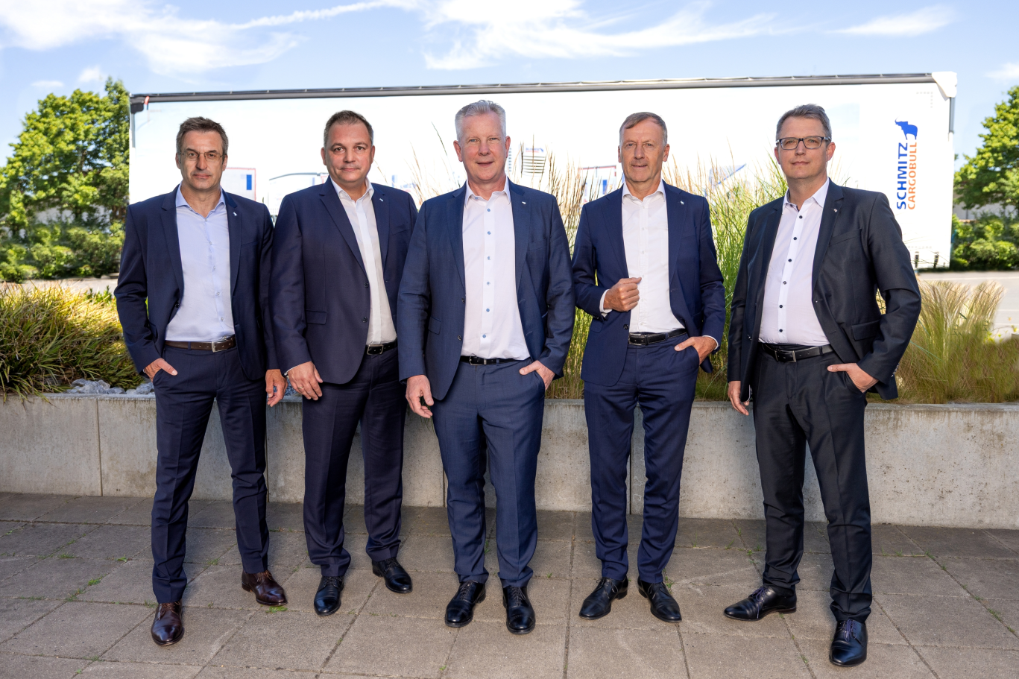
Board of Schmitz Cargobull (f.l. Dr. Günter Schweitzer (COO), Ralph Kleideiter (CSO), Andreas Schmitz (CEO), Andreas Busacker (CFO), Marnix Lannoije (CTO))

About Schmitz Cargobull
Schmitz Cargobull is the leading manufacturer of semi-trailers for temperature-controlled freight, general cargo and bulk goods in Europe, and a pioneer in digital solutions for trailer services and improved connectivity. The company also manufactures transport cooling units for refrigerated box body semi-trailers for temperature-controlled freight transport. With a comprehensive range of services from financing, spare parts supply, service contracts and telematics solutions to used vehicle trading, Schmitz Cargobull supports its customers in optimising their total cost of ownership (TCO) and digital transformation.
Schmitz Cargobull was founded in 1892 in Münsterland, Germany. The family-run company produces around 50,000 vehicles per year with over 6,000 employees and generated a turnover of around €2.25 billion in the financial year 2025/26.
Its international production network is made up of factories in Germany, Lithuania, Spain, Turkey, Romania and the UK.

The Schmitz Cargobull press team:
Anna Stuhlmeier +49 2558 81-1340 I anna.stuhlmeier@cargobull.com
Andrea Beckonert +49 2558 81-1321 I andrea.beckonert@cargobull.com
Silke Hesener +49 2558 81-1501 I silke.hesener@cargobull.com

